REPORT WIND ENGINEERING PROJECT

1. Analysis with lambda = 1, tau_roll=0.664
   1. layout immagini
   2. come mettiamo giù le informazioni
   3. mettiamo tutto?
2. Analysis with lambda variation
3. Analysis with tau_roll variation

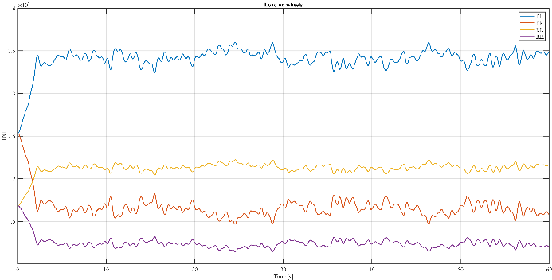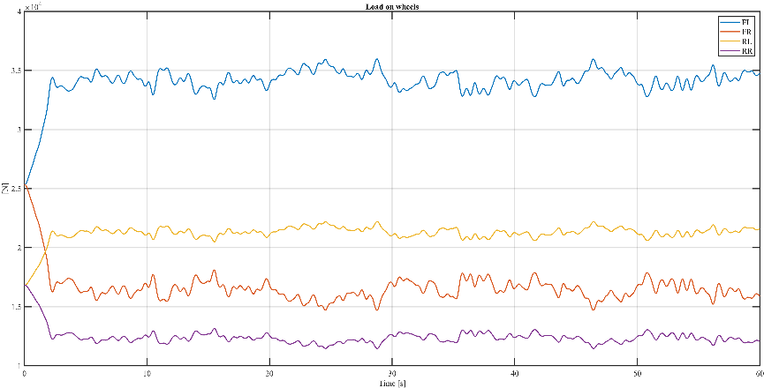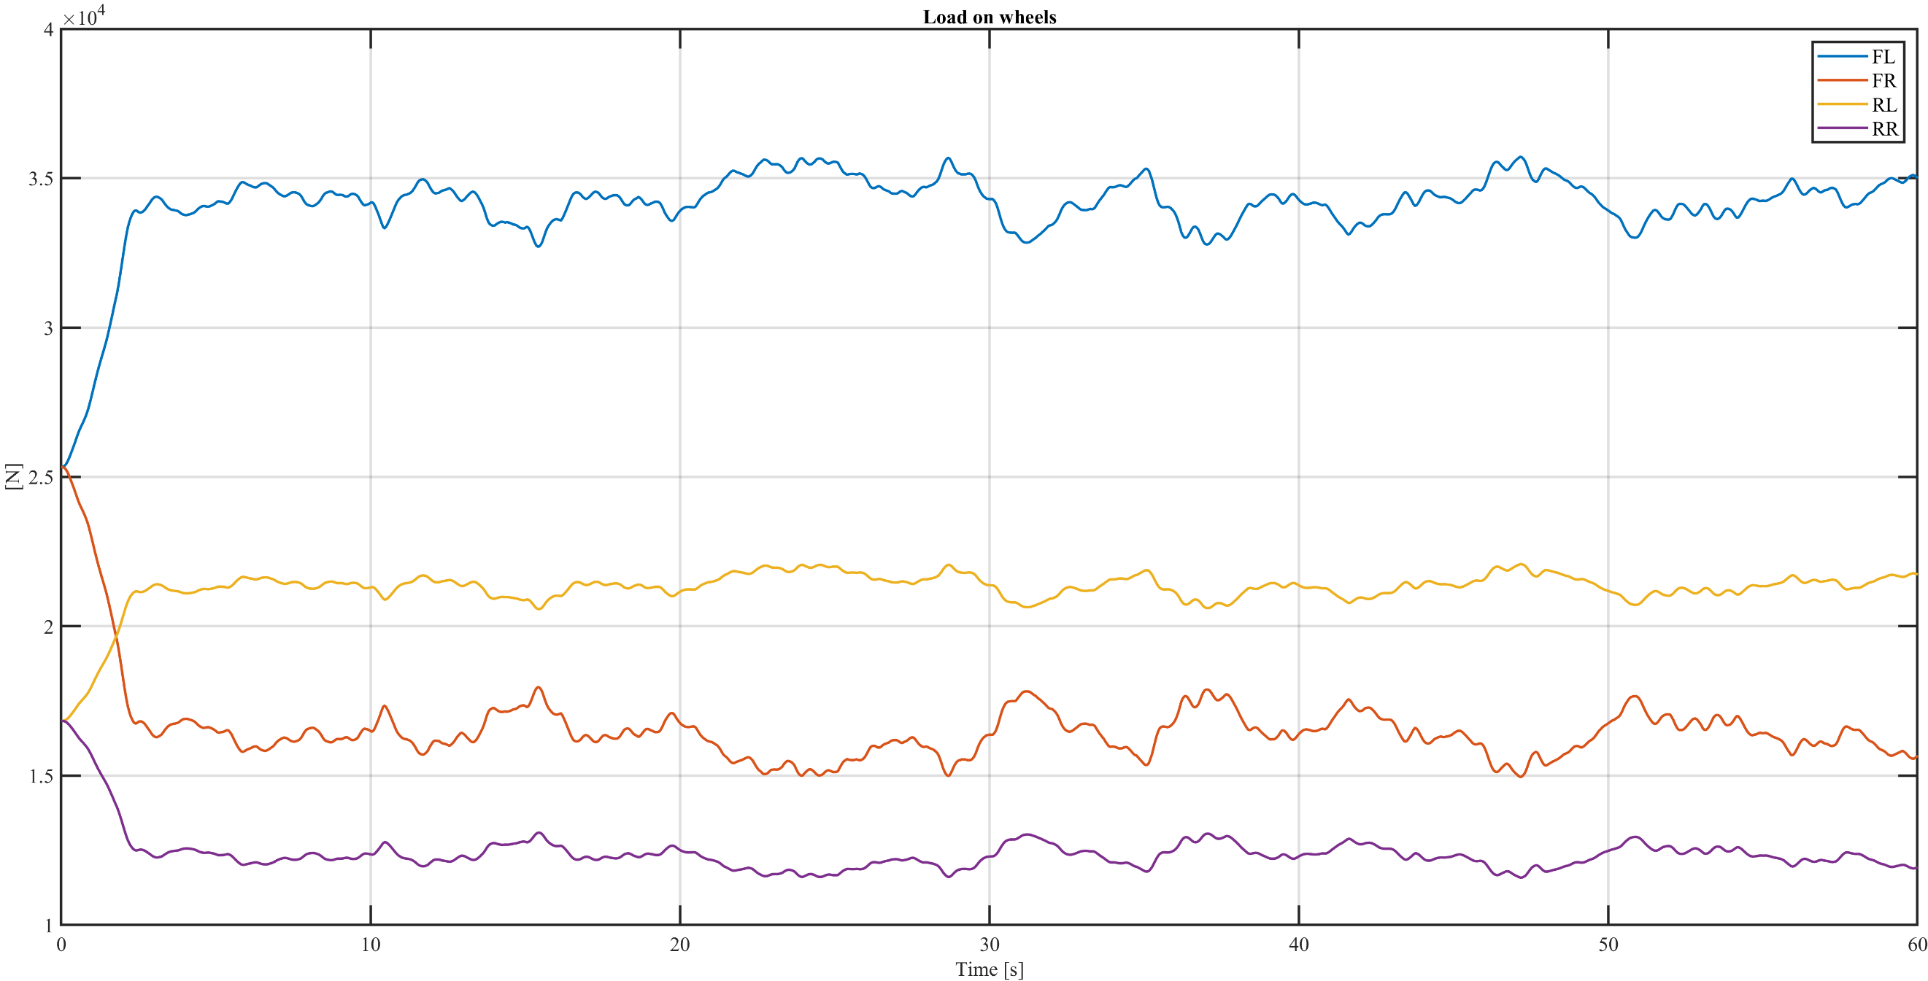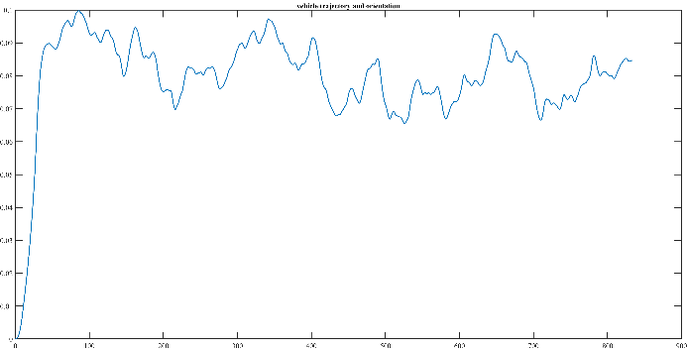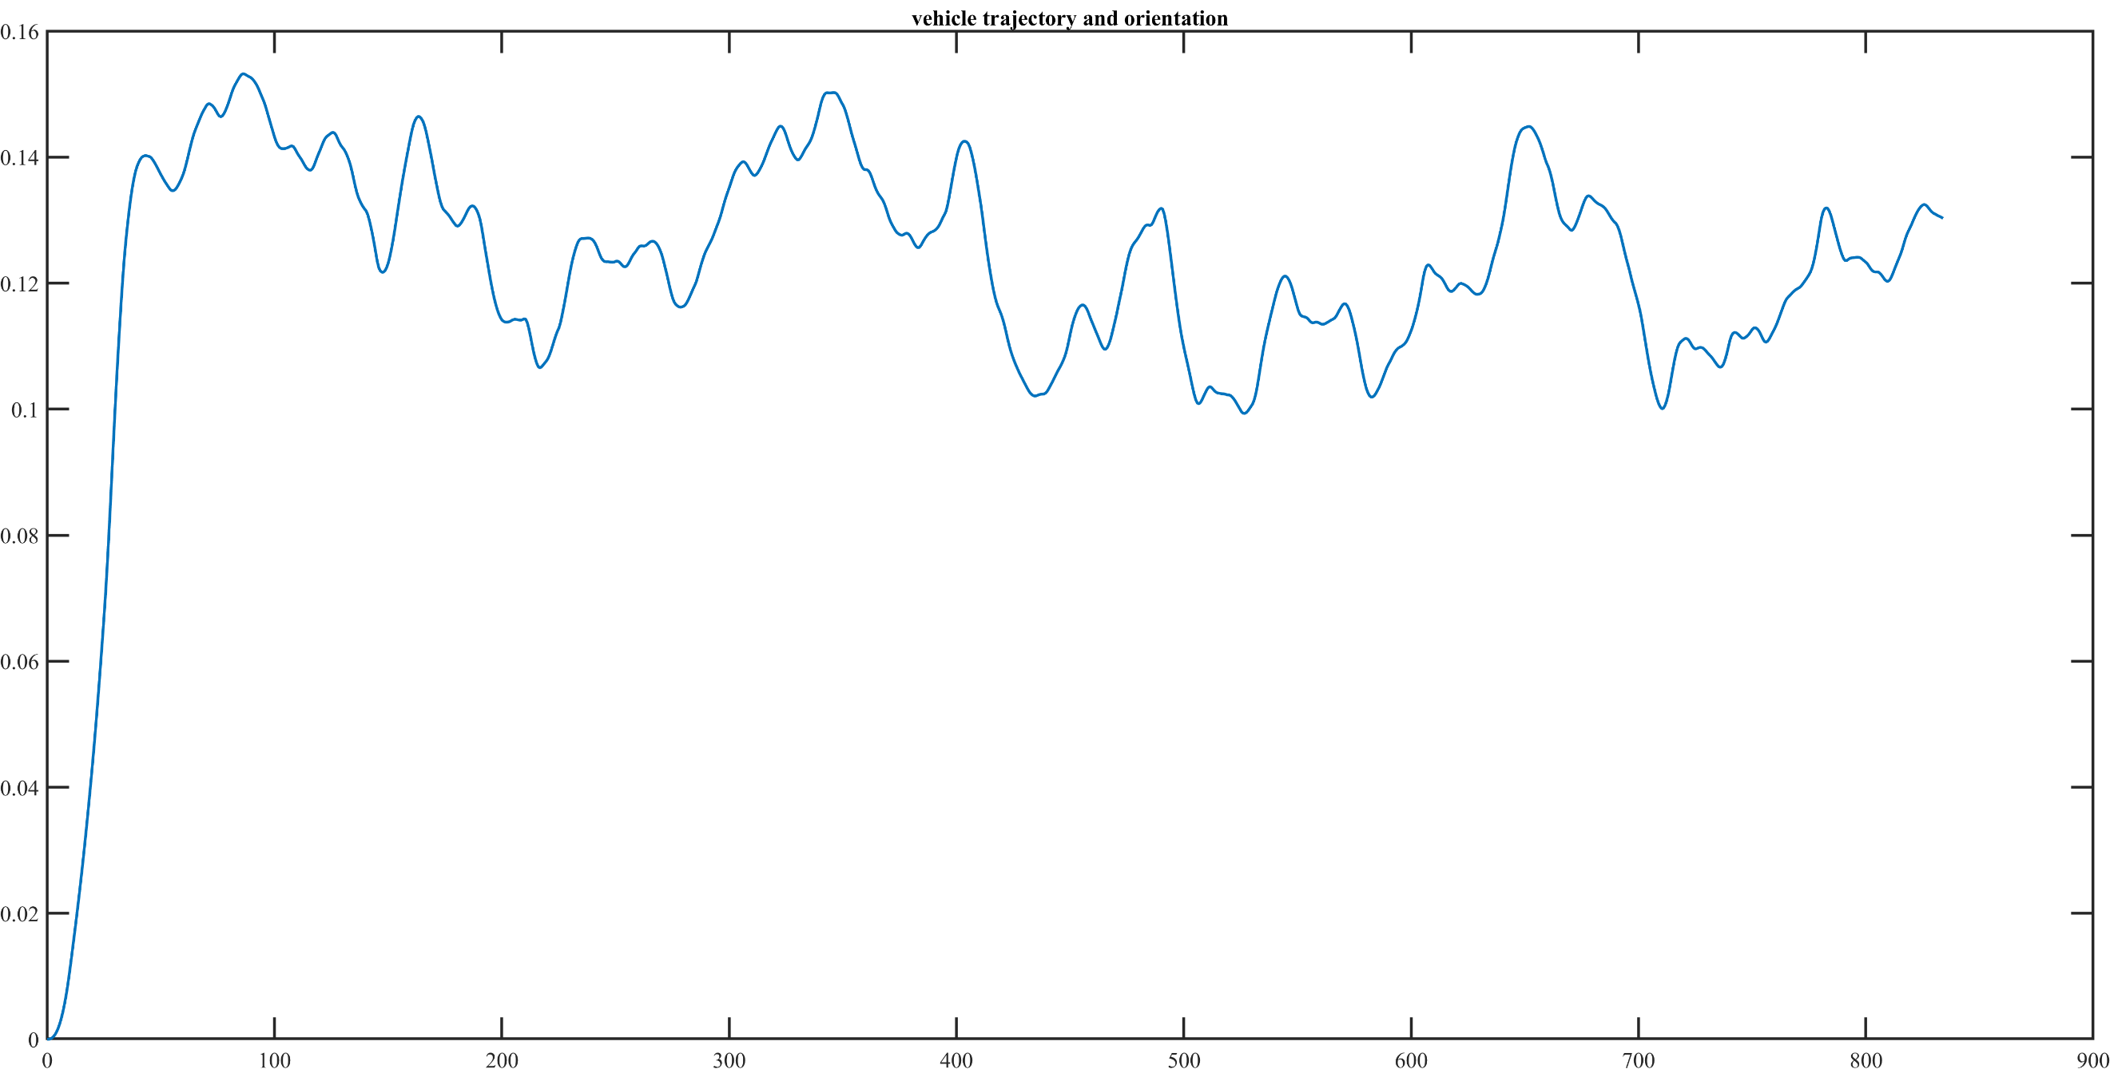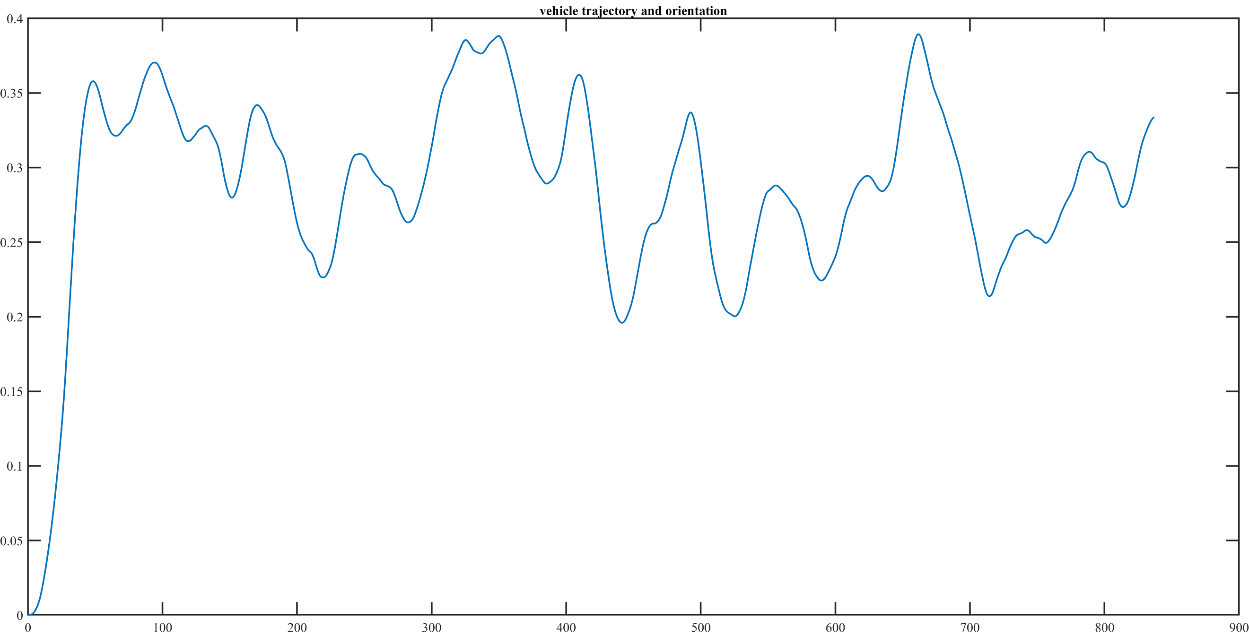

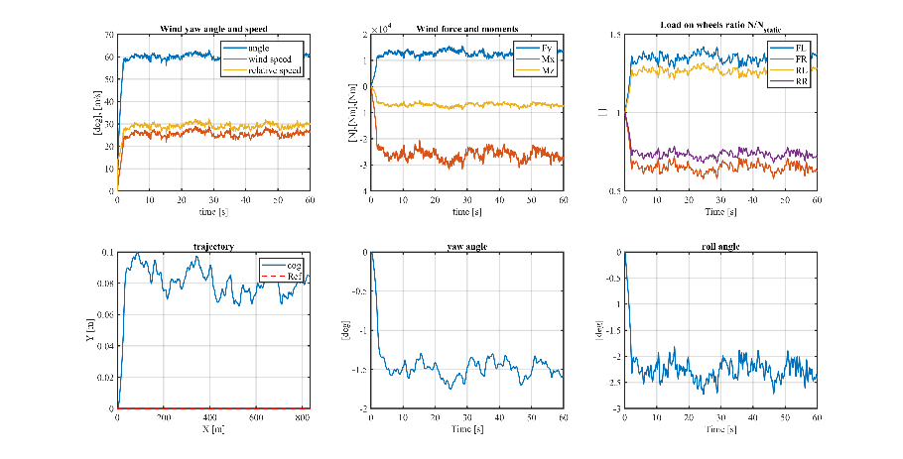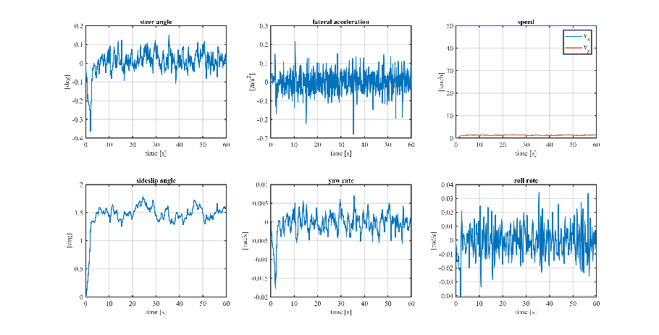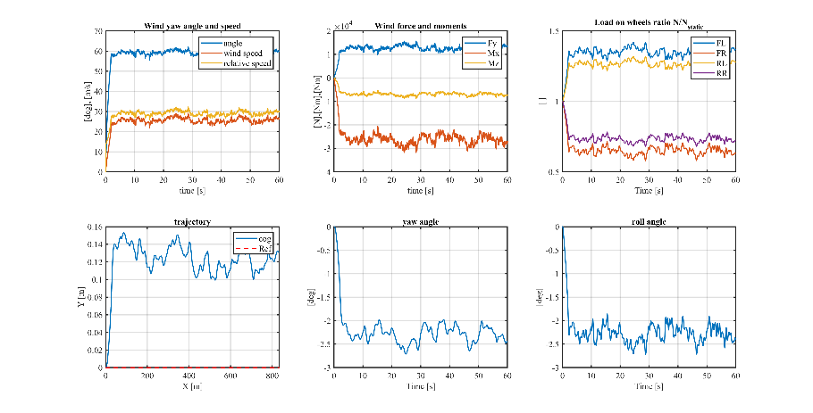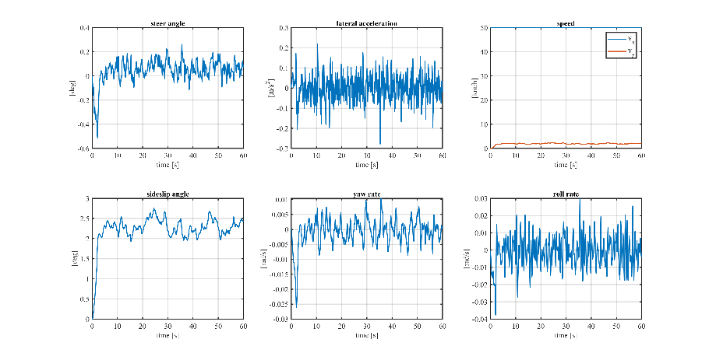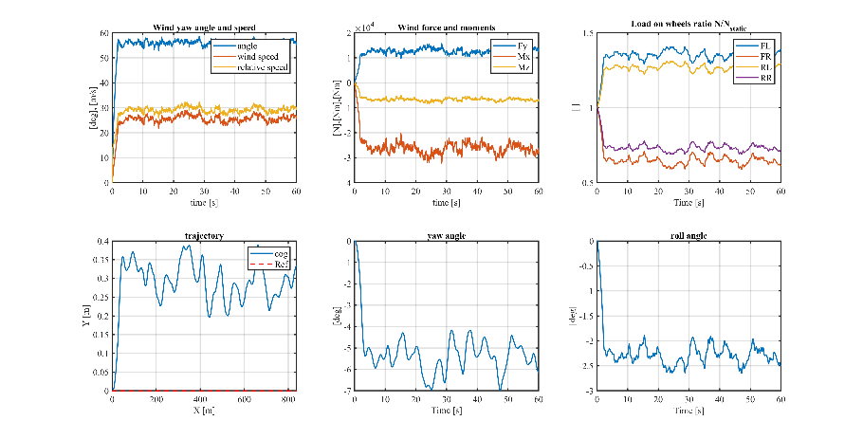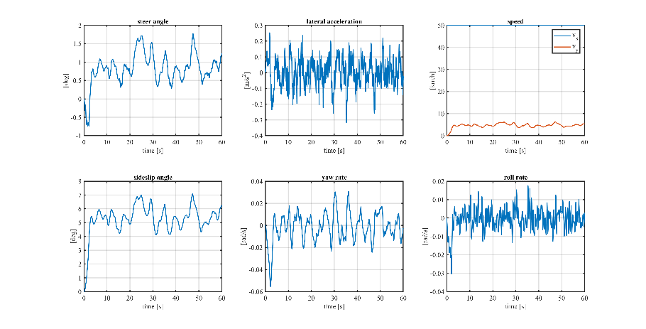

Lambda = 0.25, Dry, si ribalta, metterei la foto delle Load on wheels e delle wind forces and moments

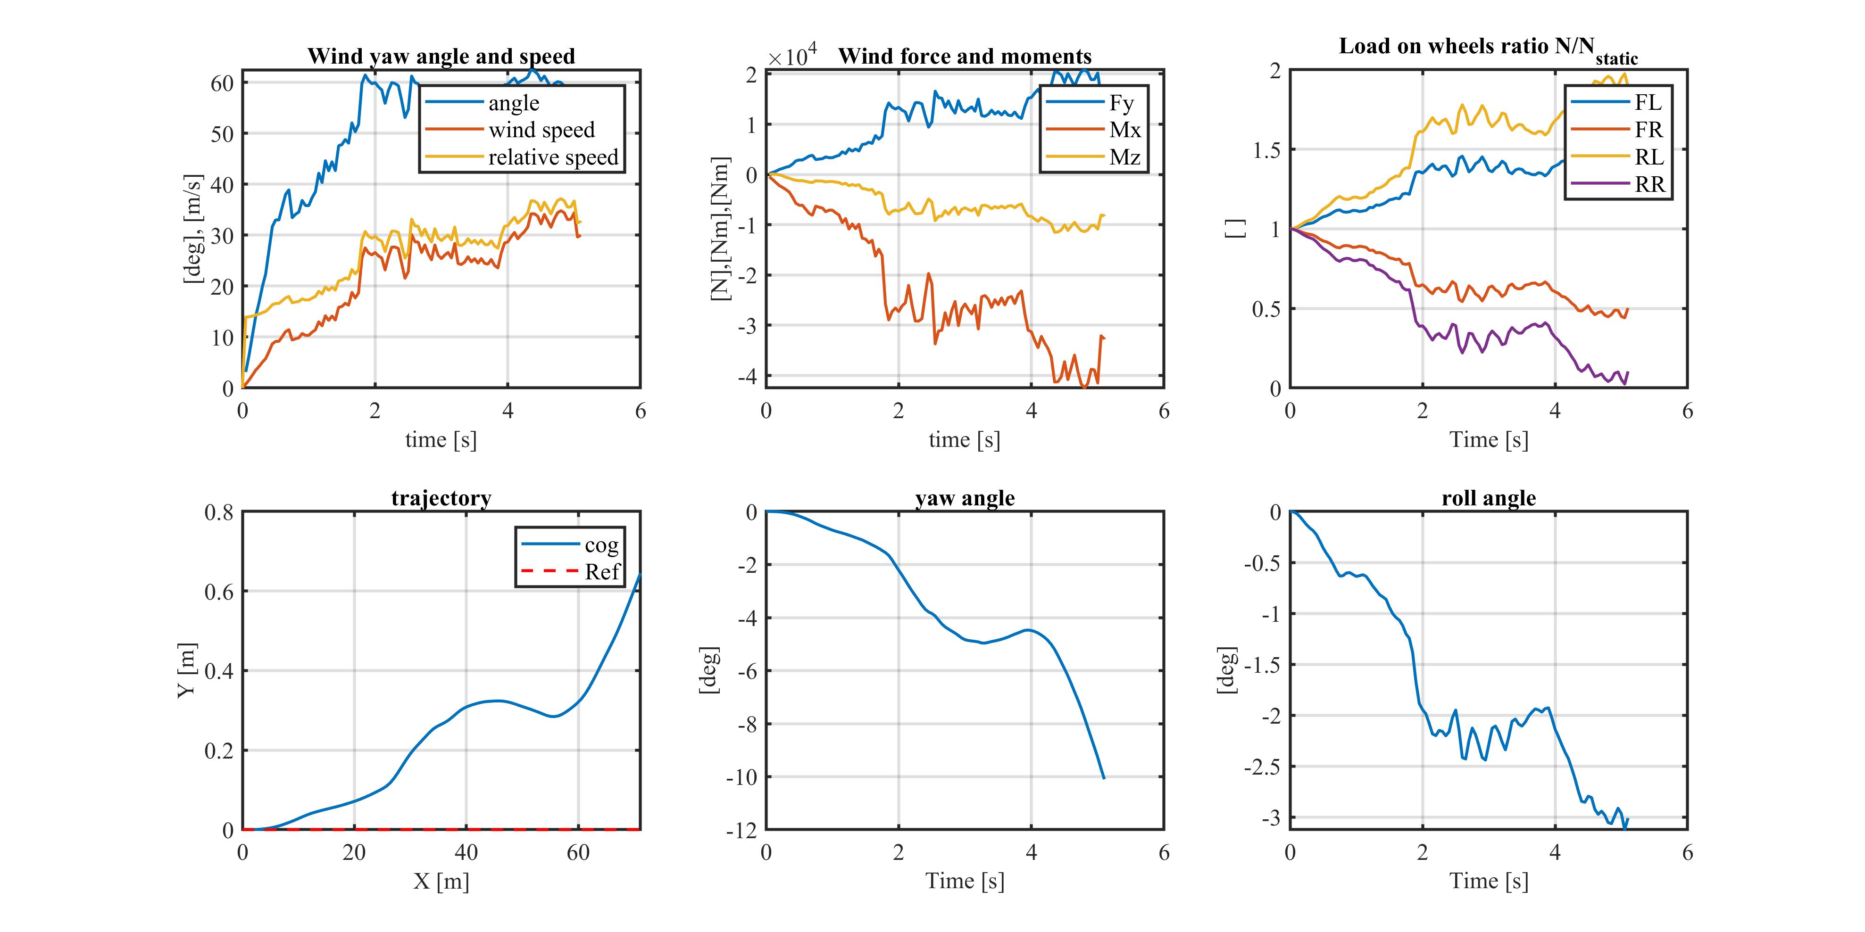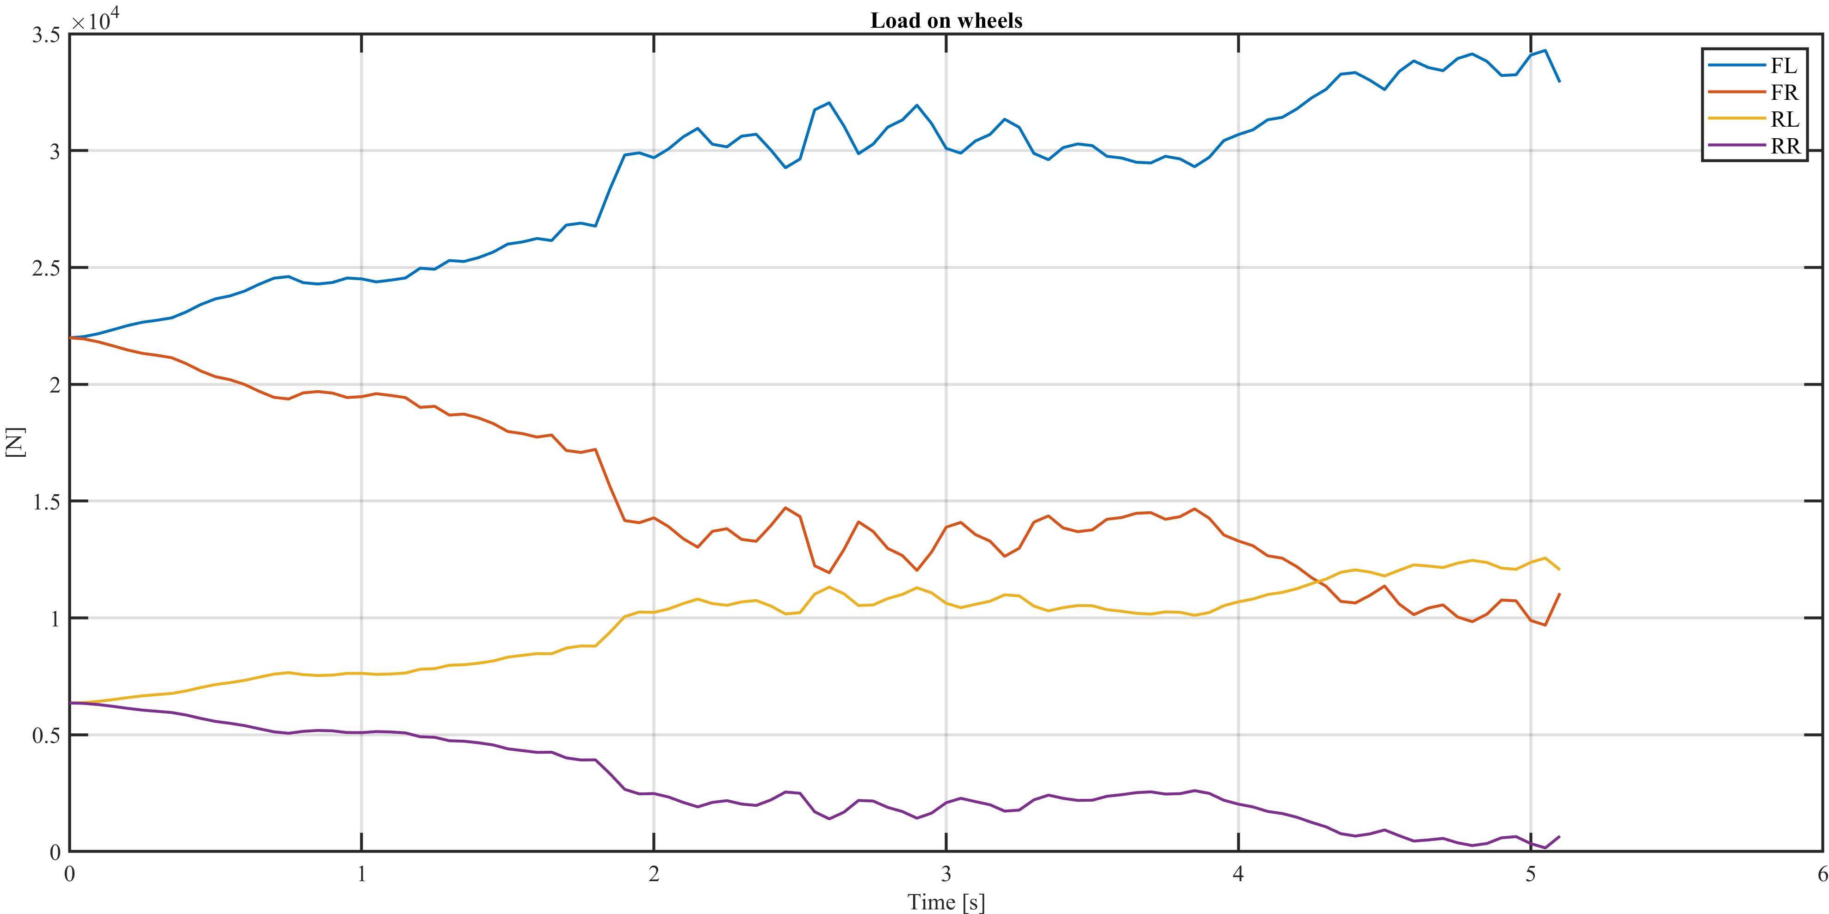

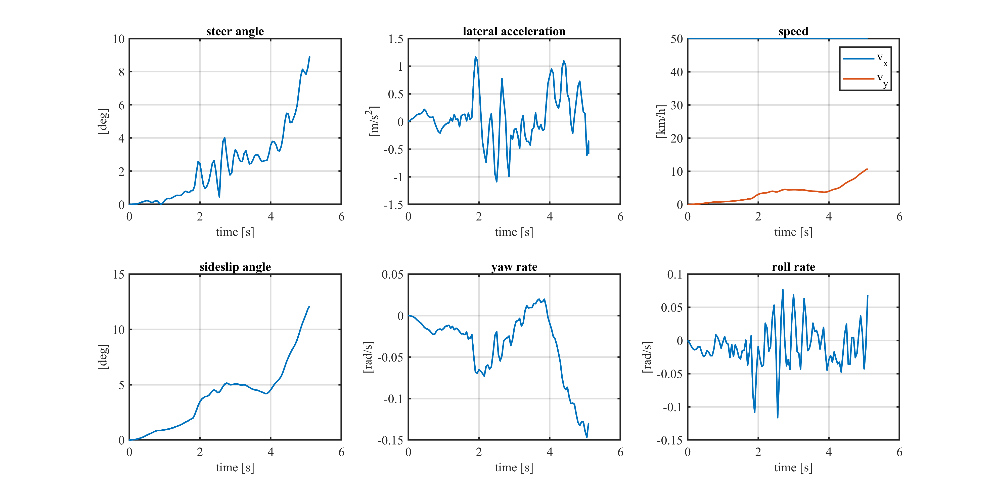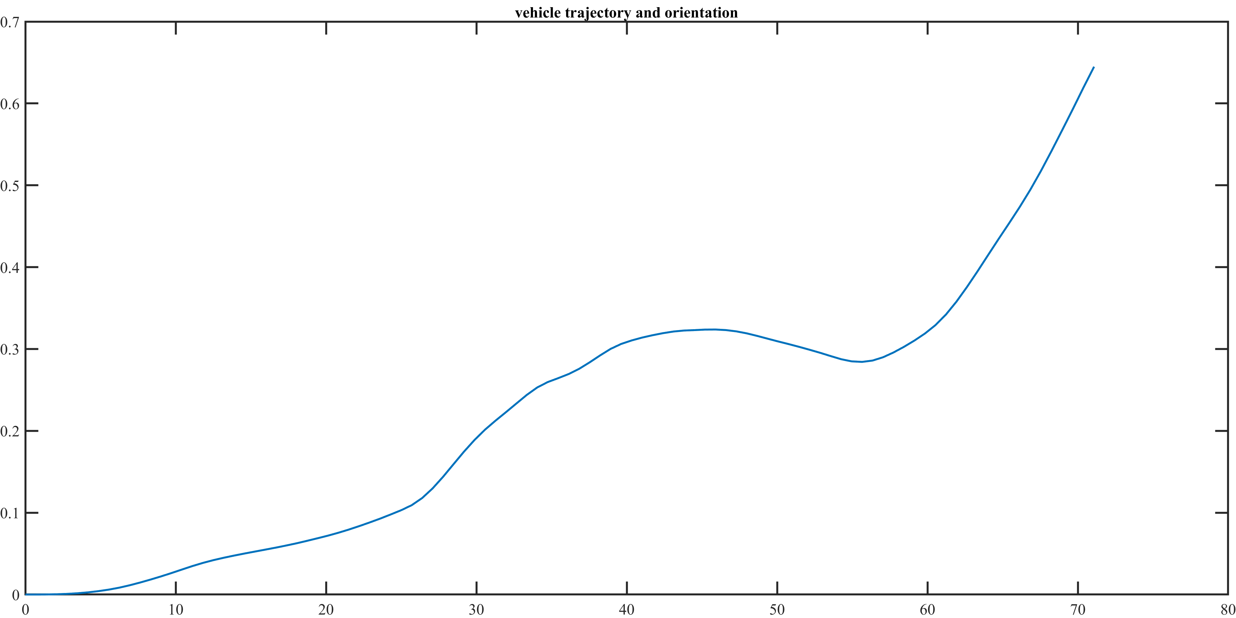

Lambda = 0.25, Wet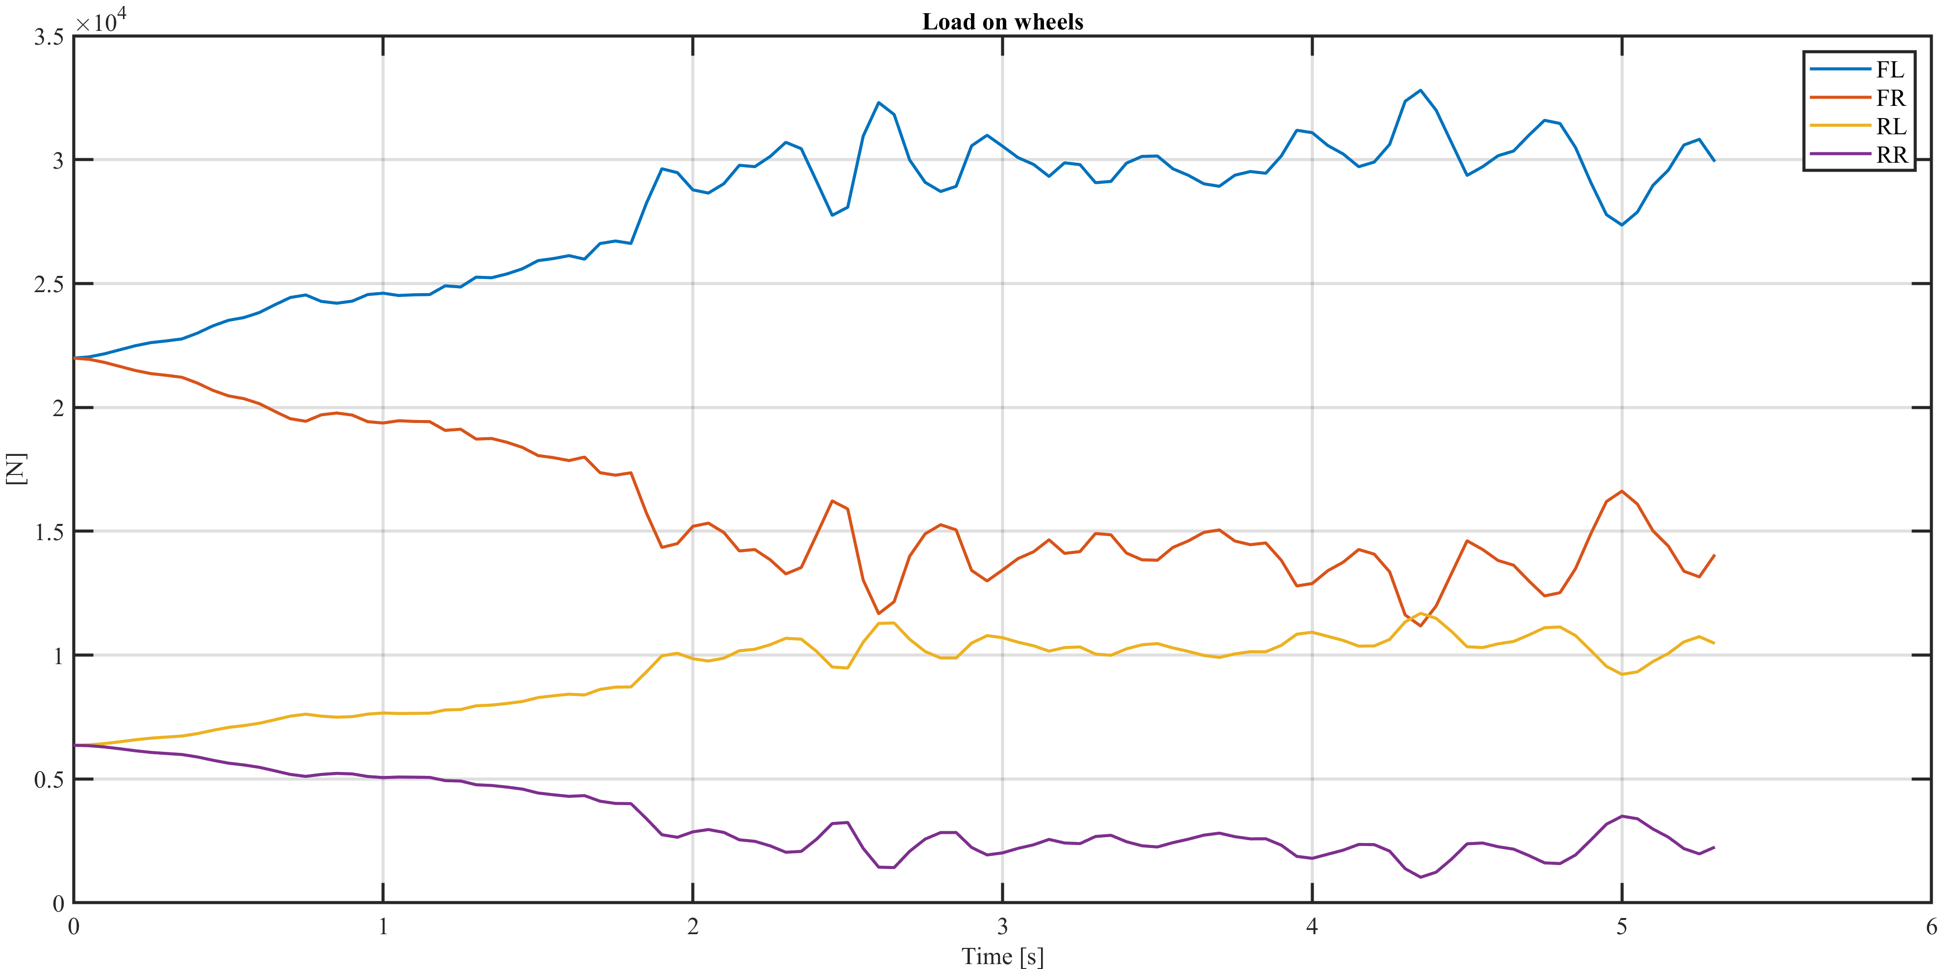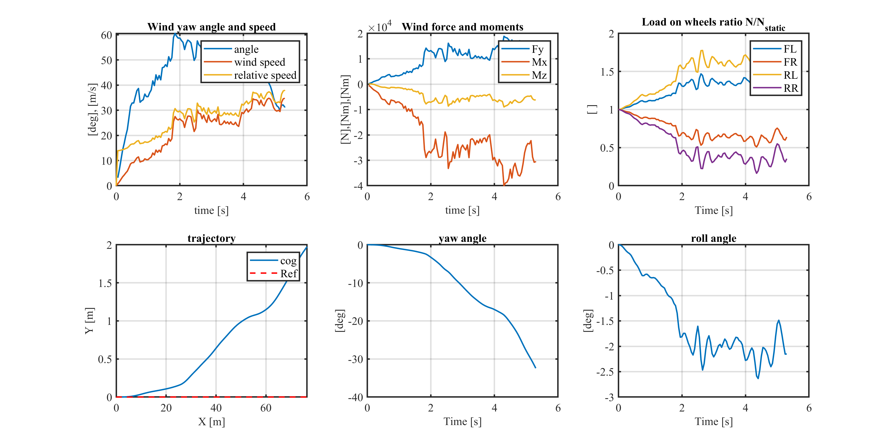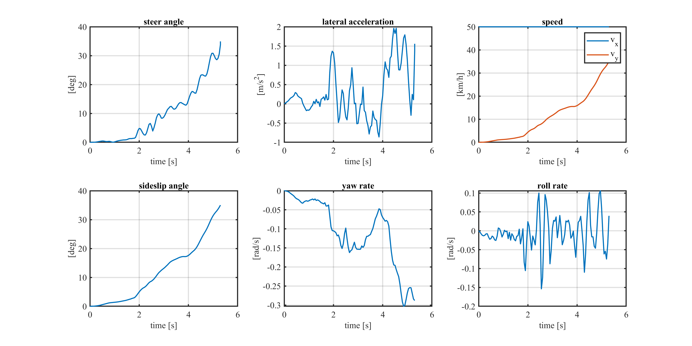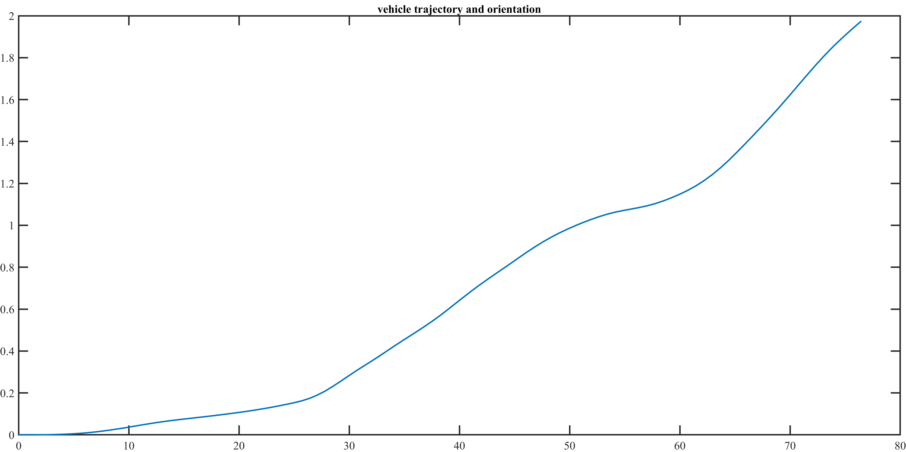, magari si può far vedere che il tempo di ribaltamento è aumentato nel load on wheels

Lambda = 0.25, Snow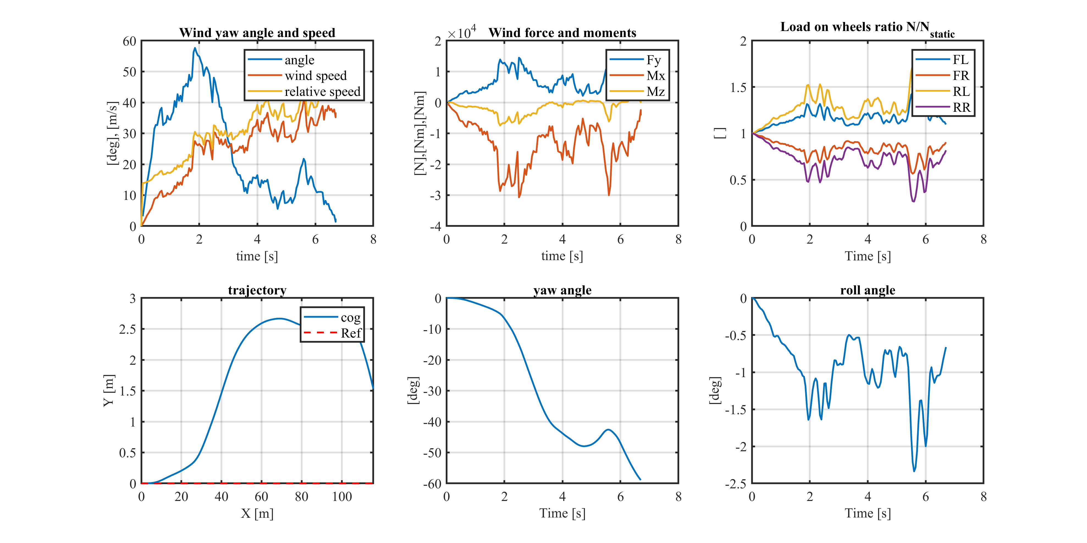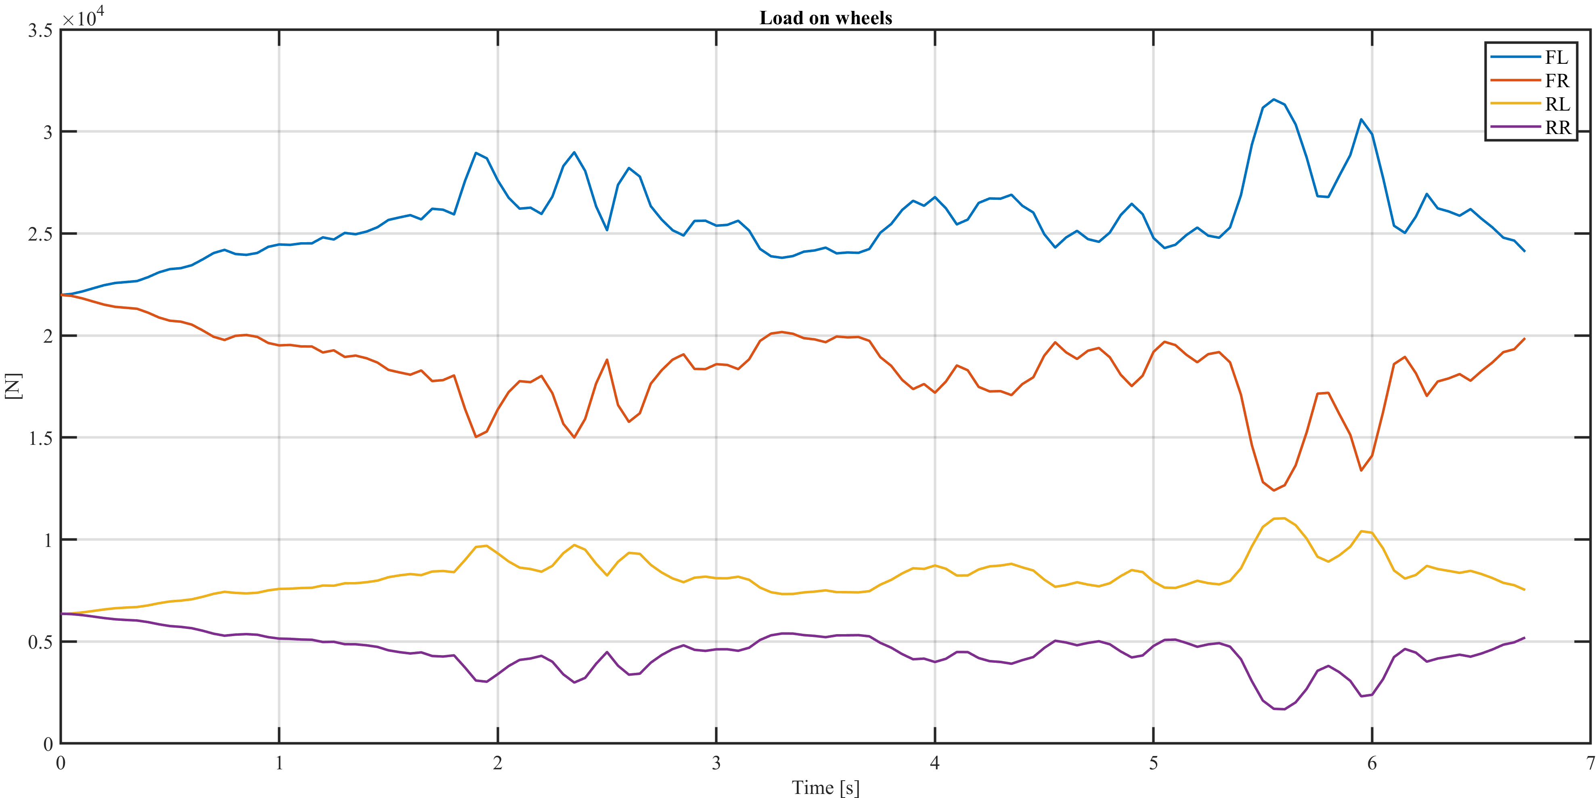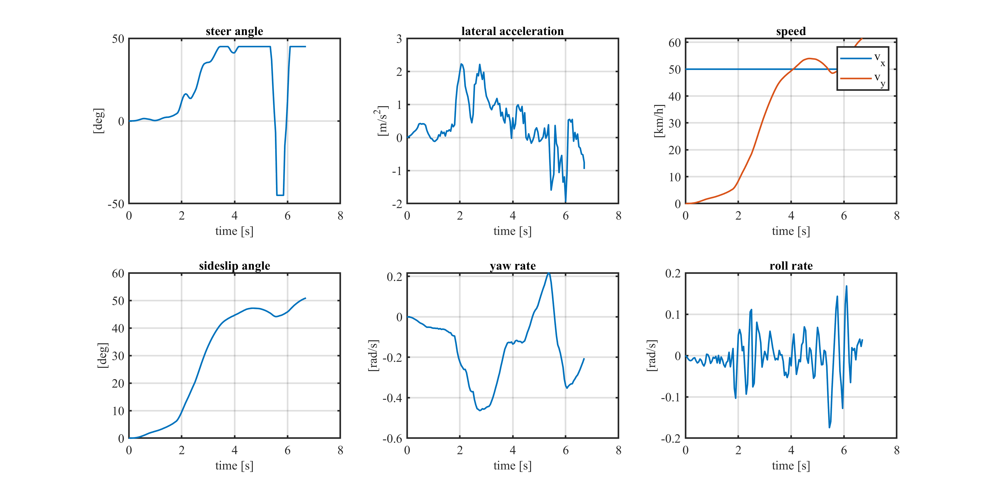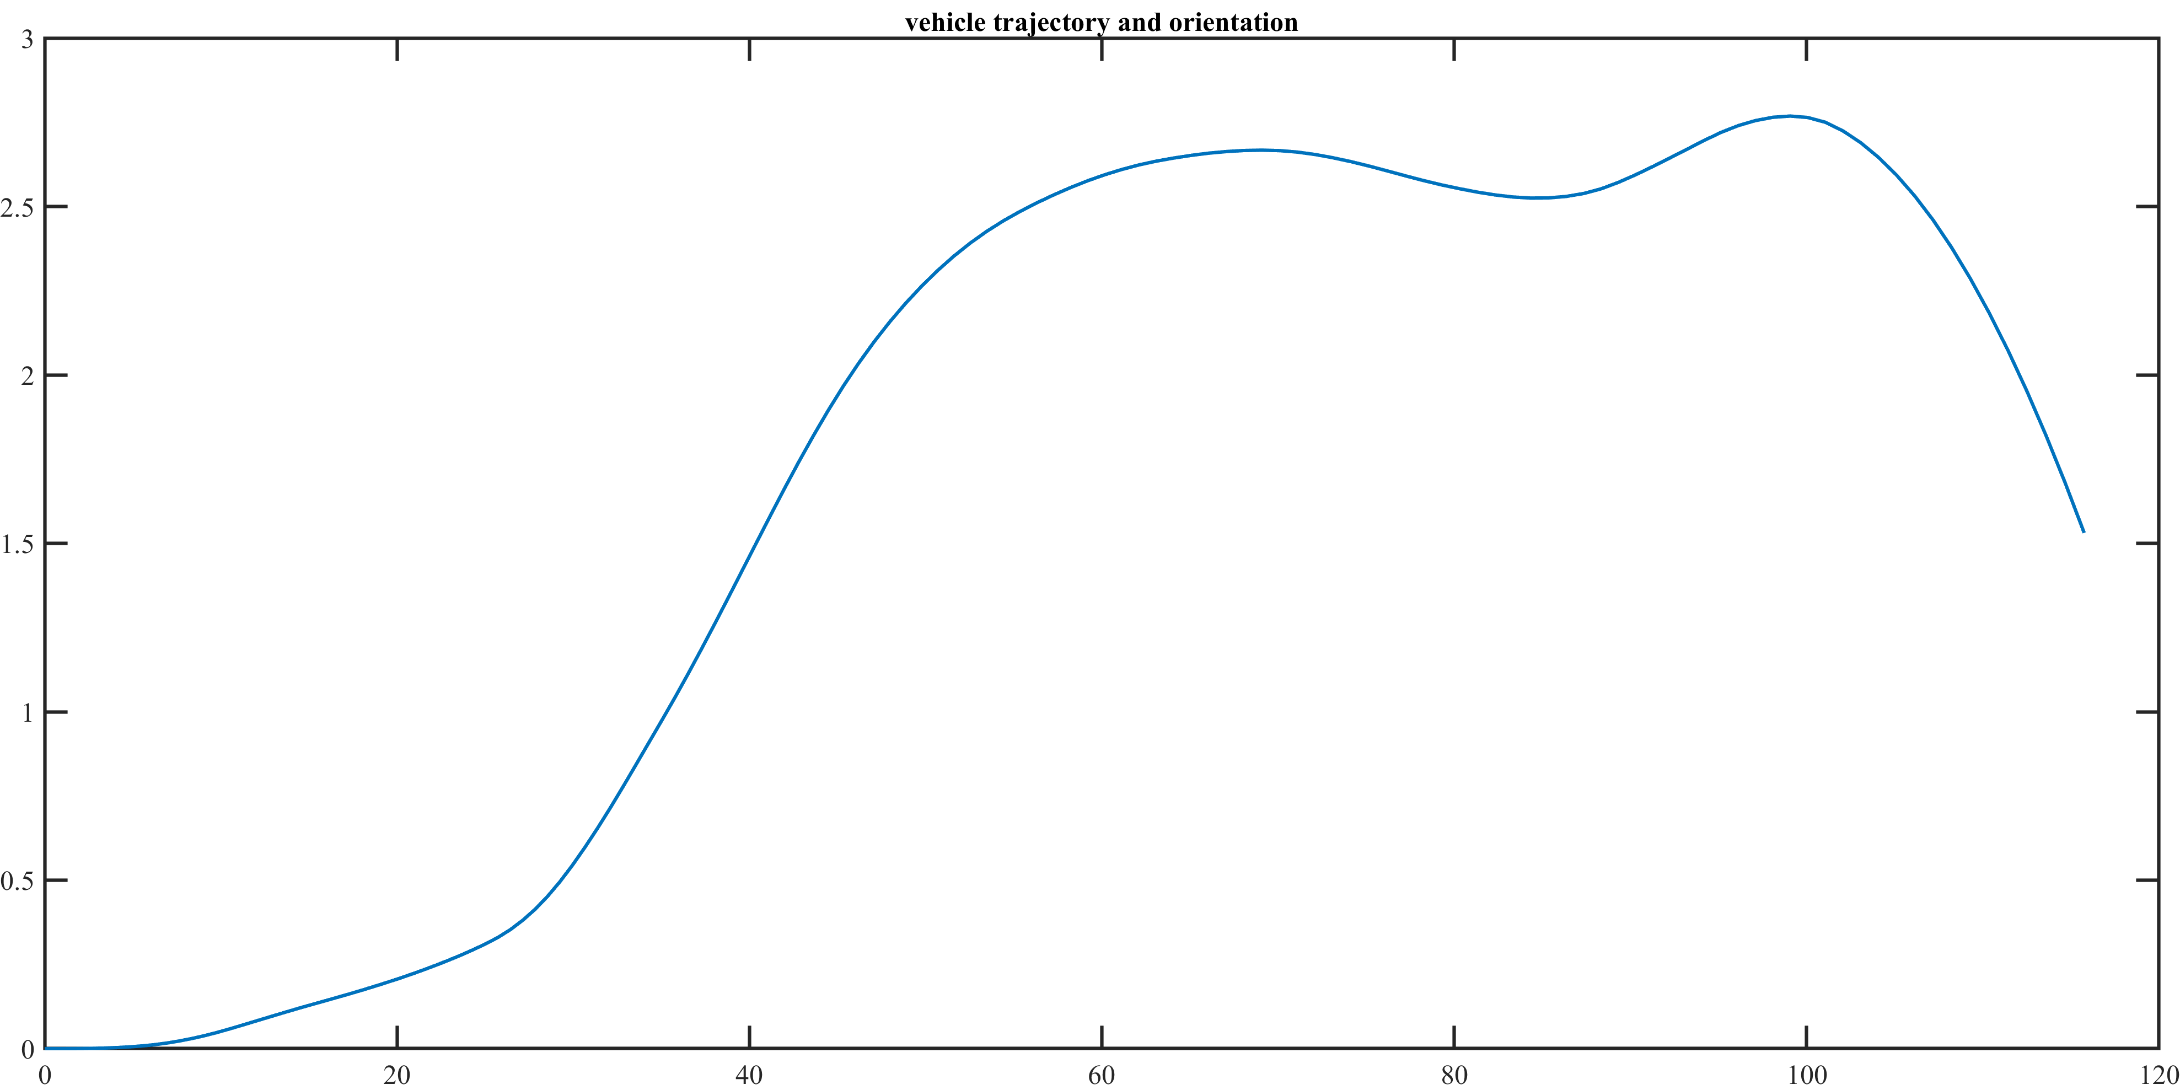, idem per il wet, questo ha tempo ancora maggiore

Lambda = 0.5, Dry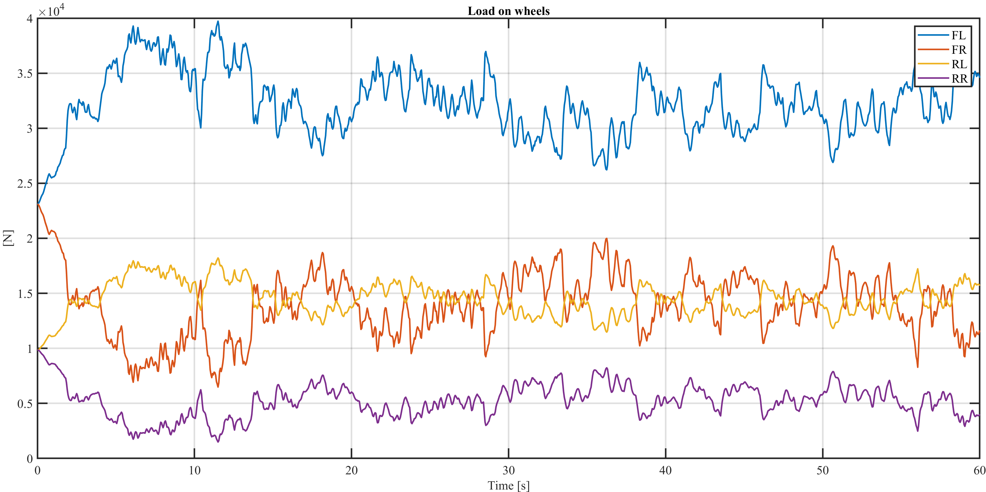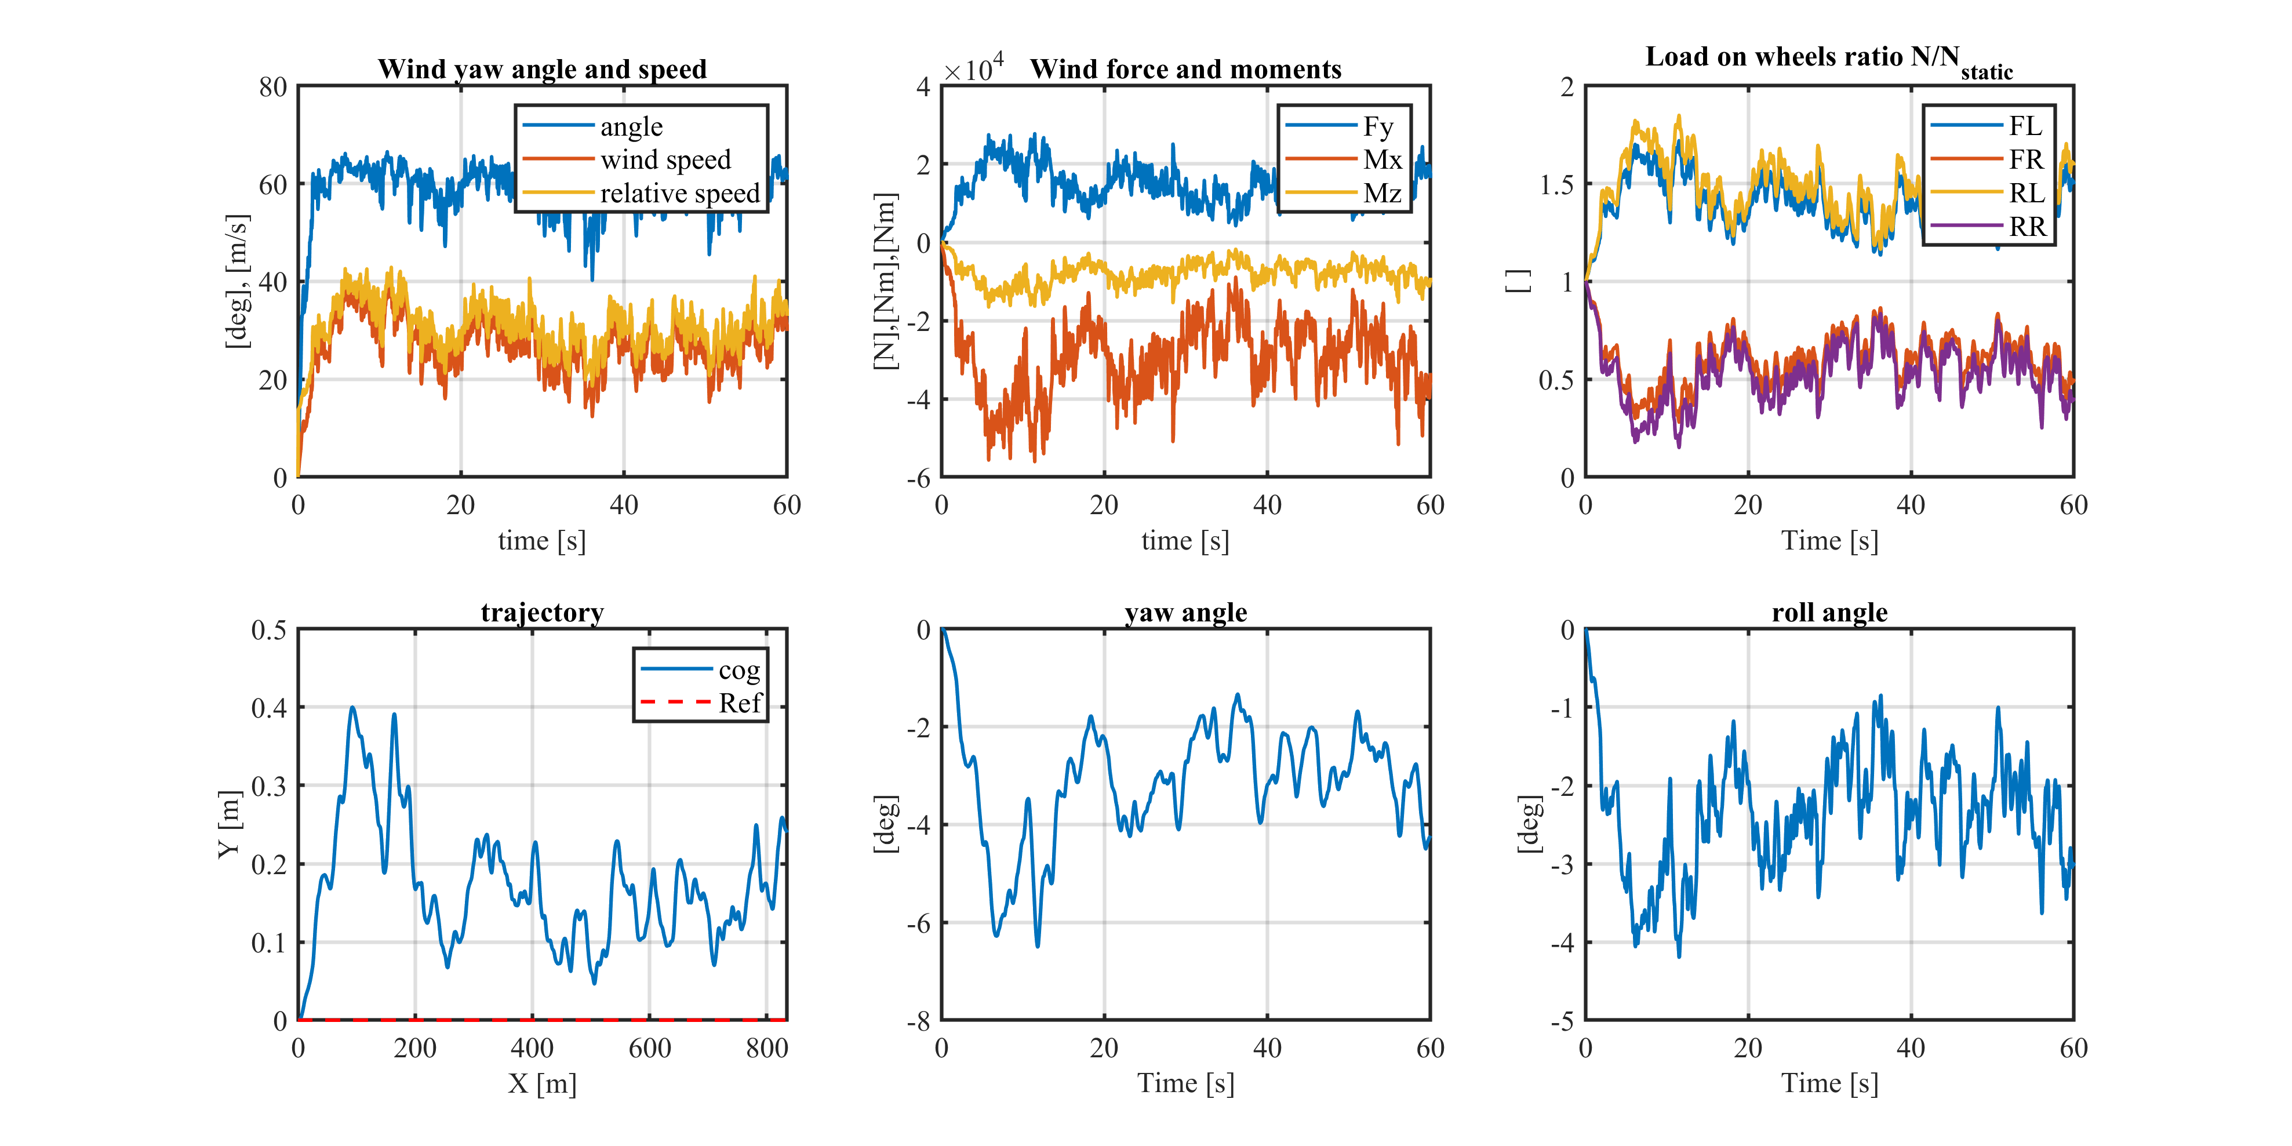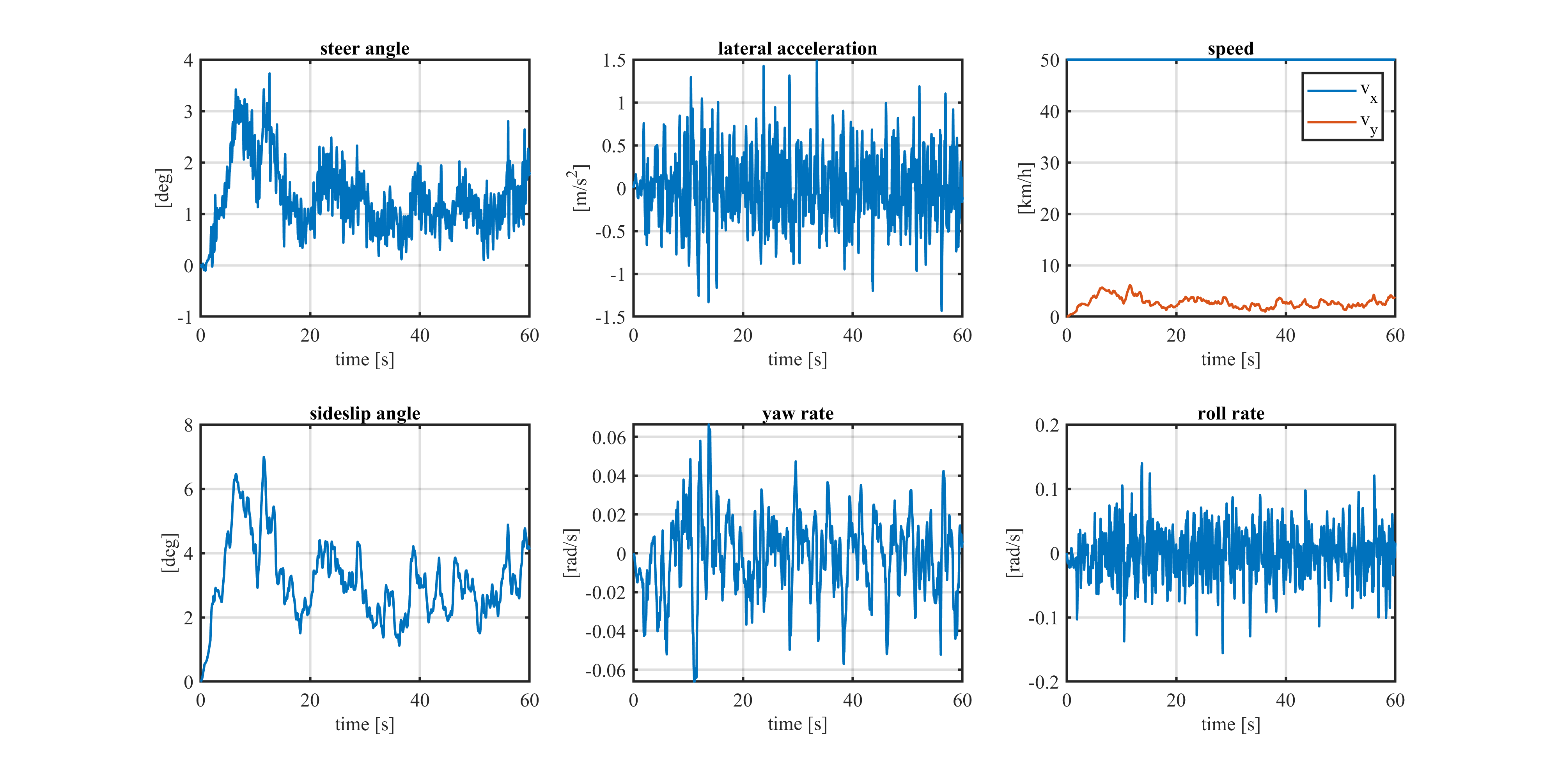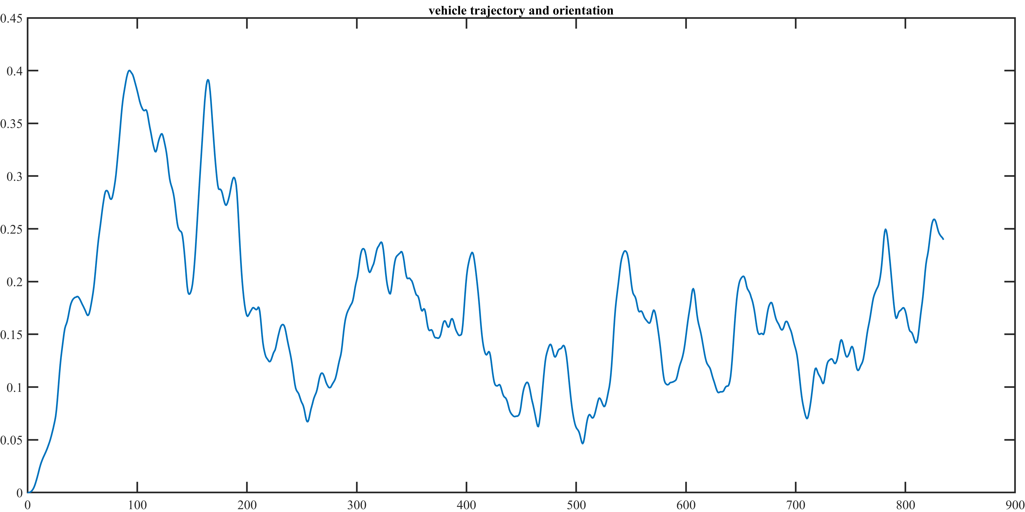, mostrare che non si ribalta ma che siamo comunque molto vicini (sempre load on wheels)

Lambda = 0.5 Wet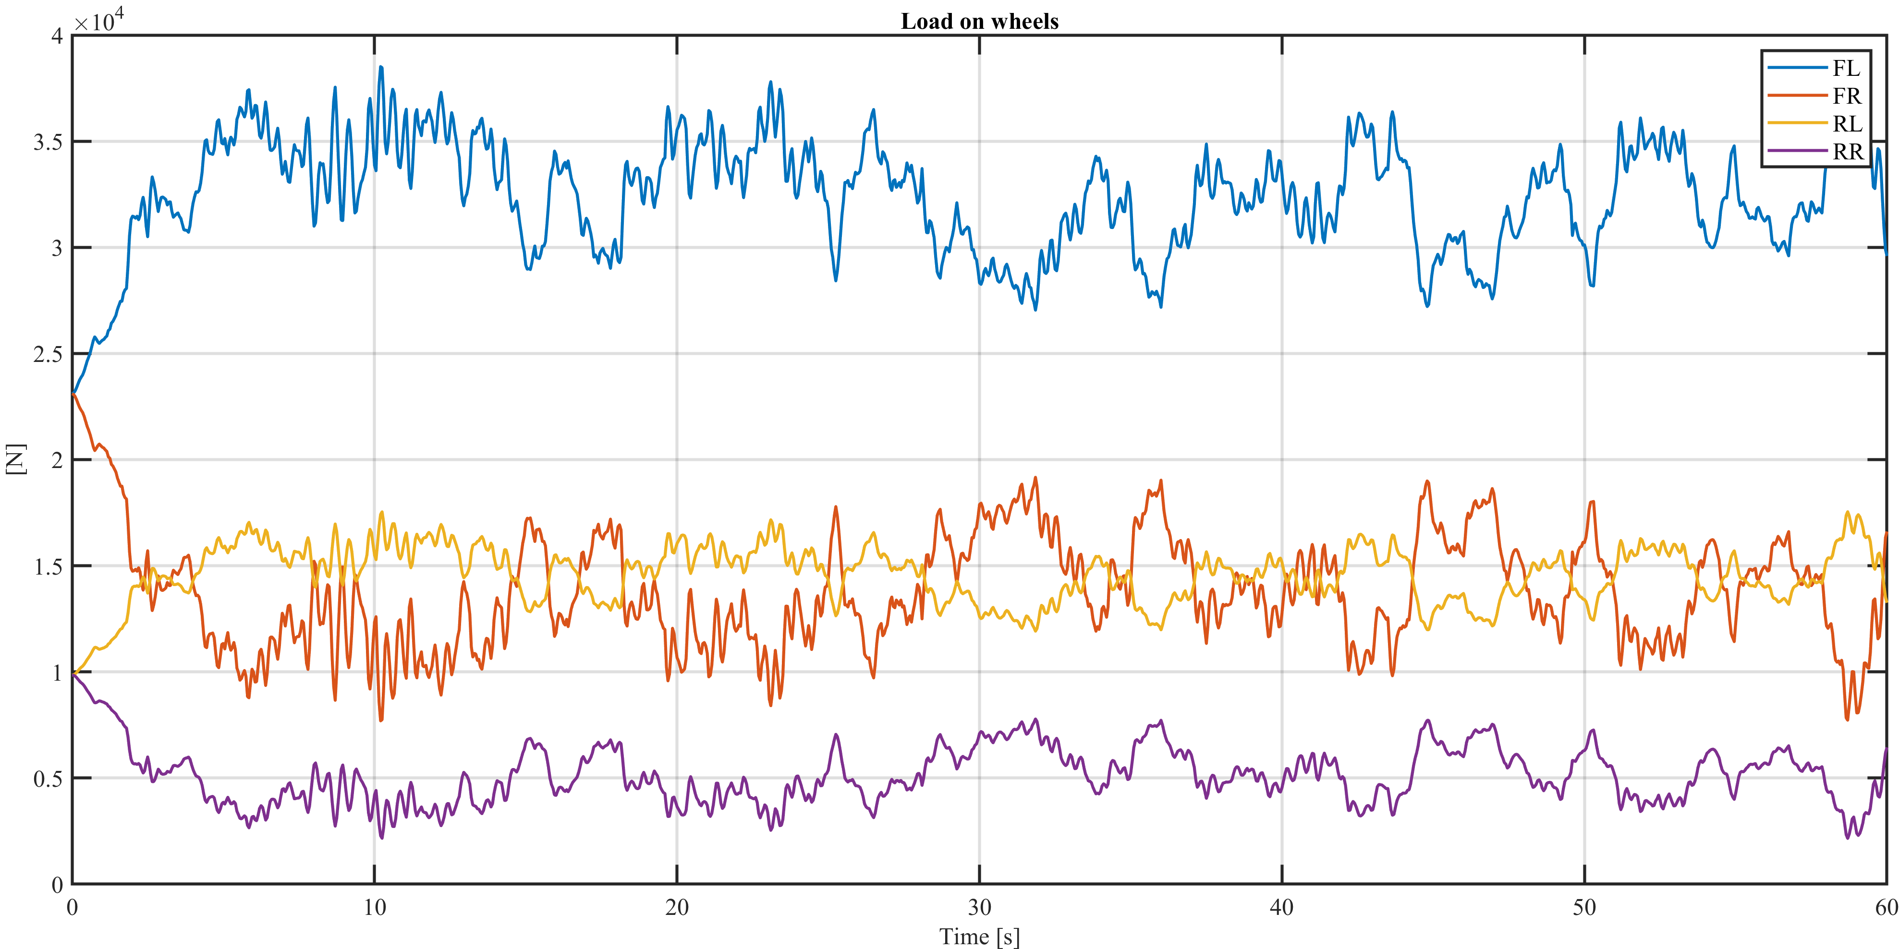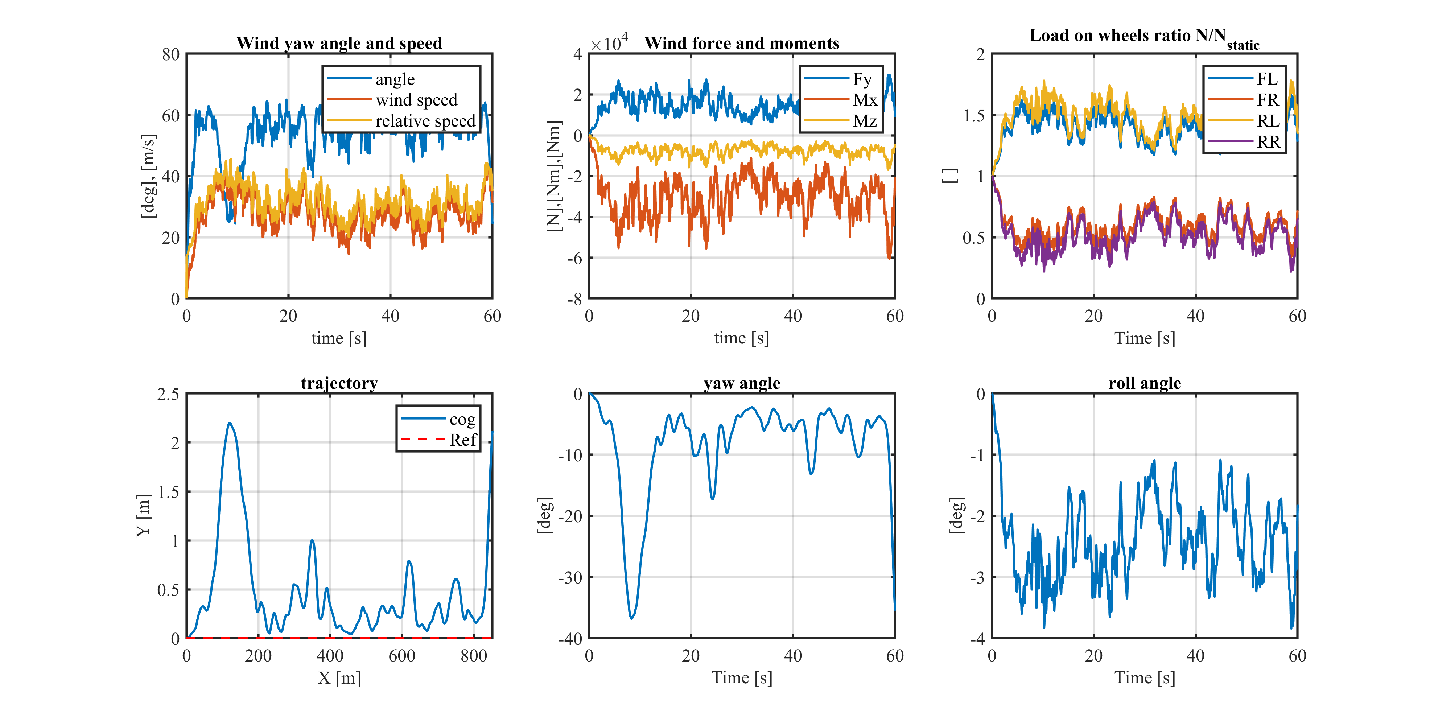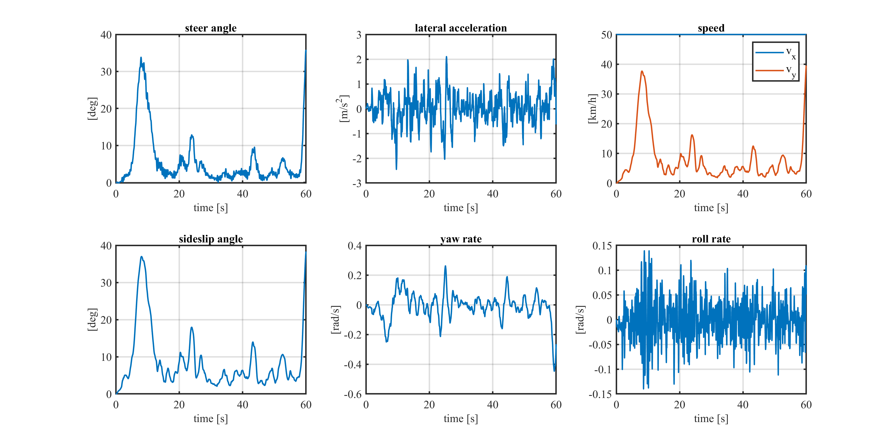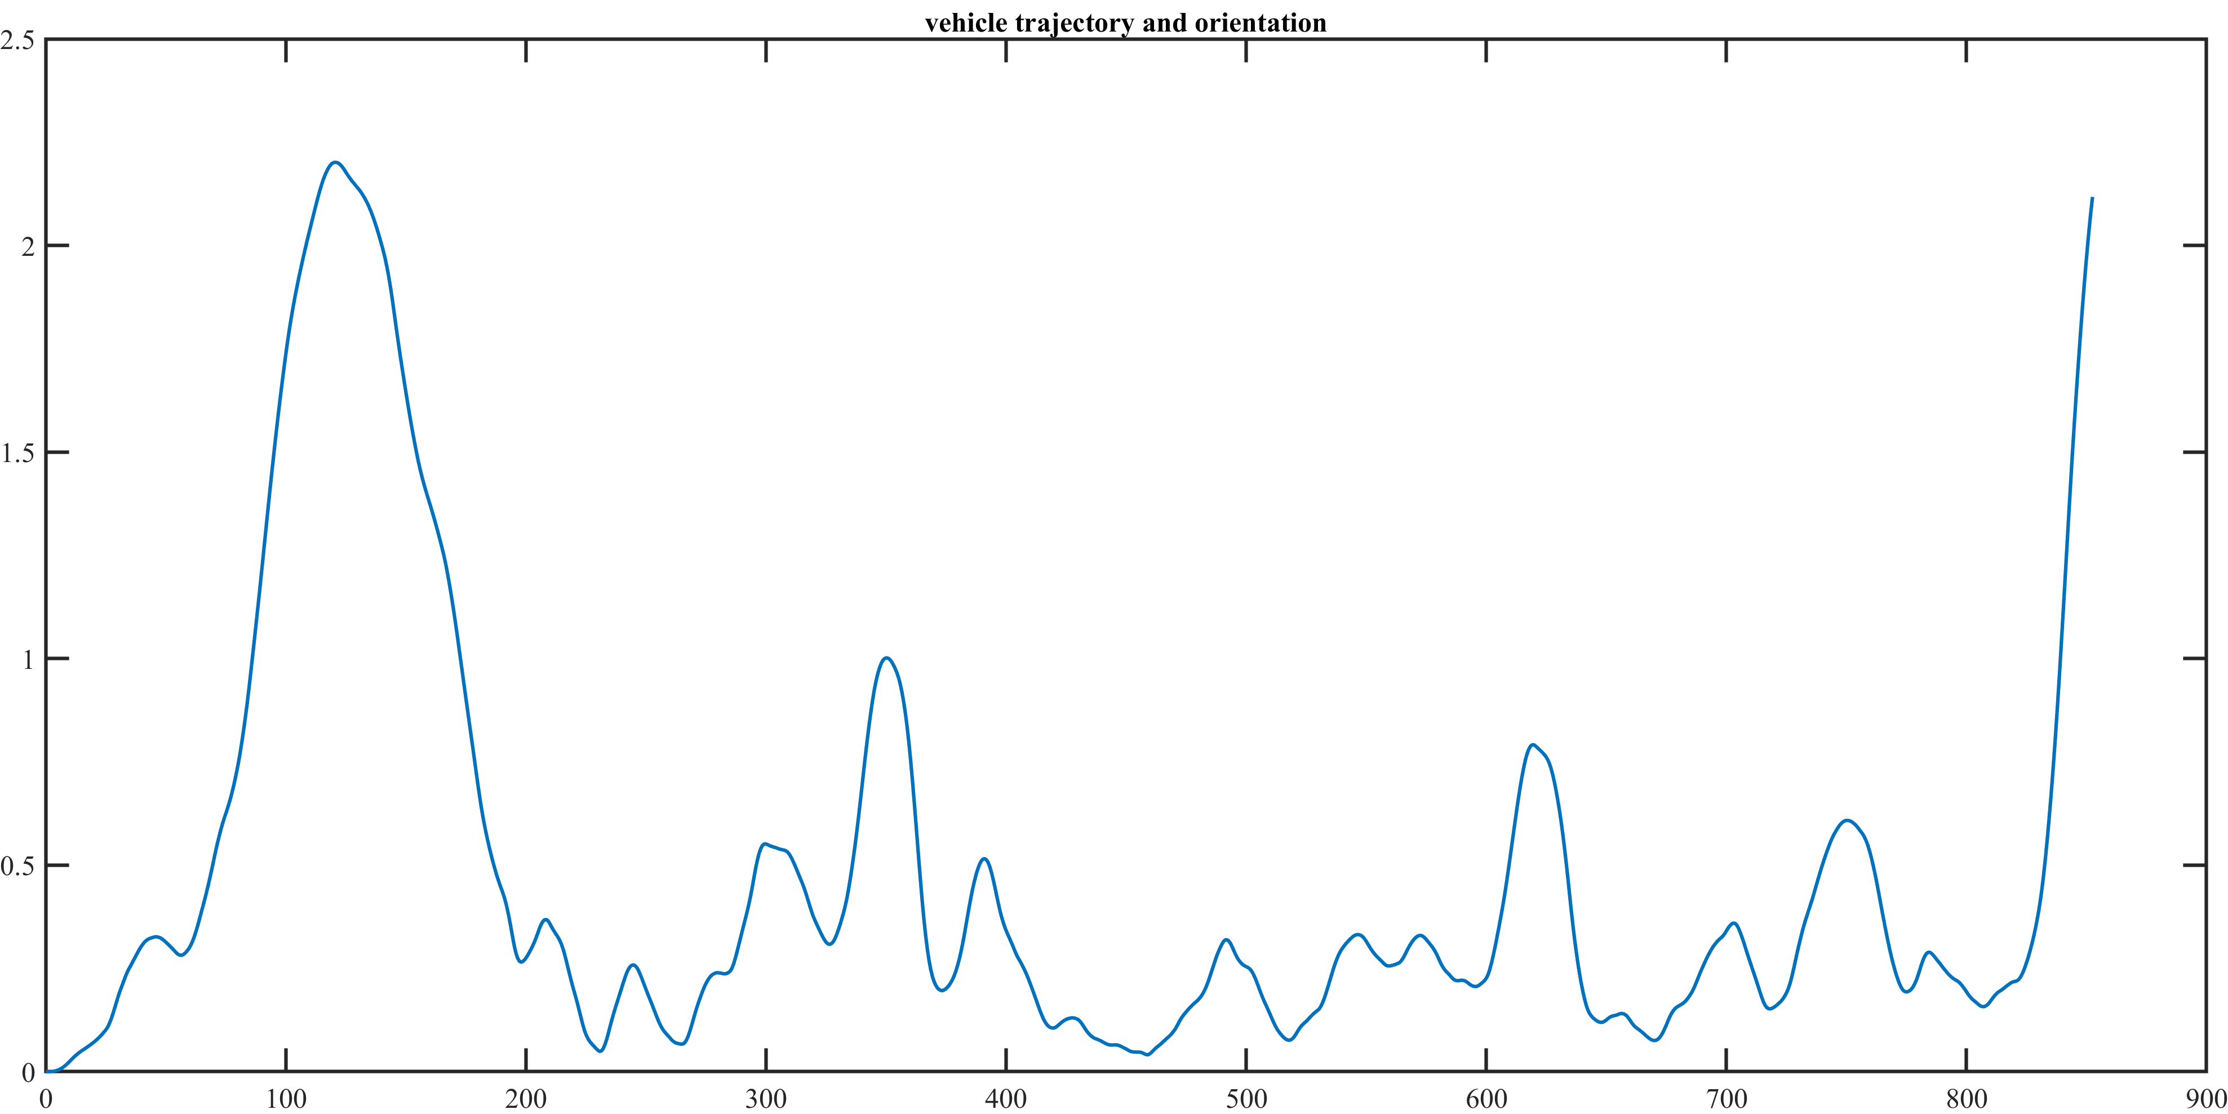

Lambda = 0.5, Snow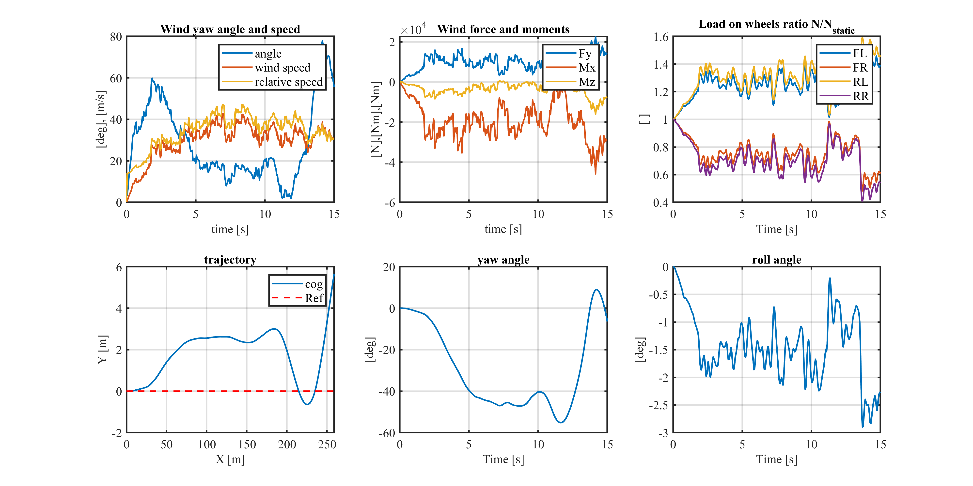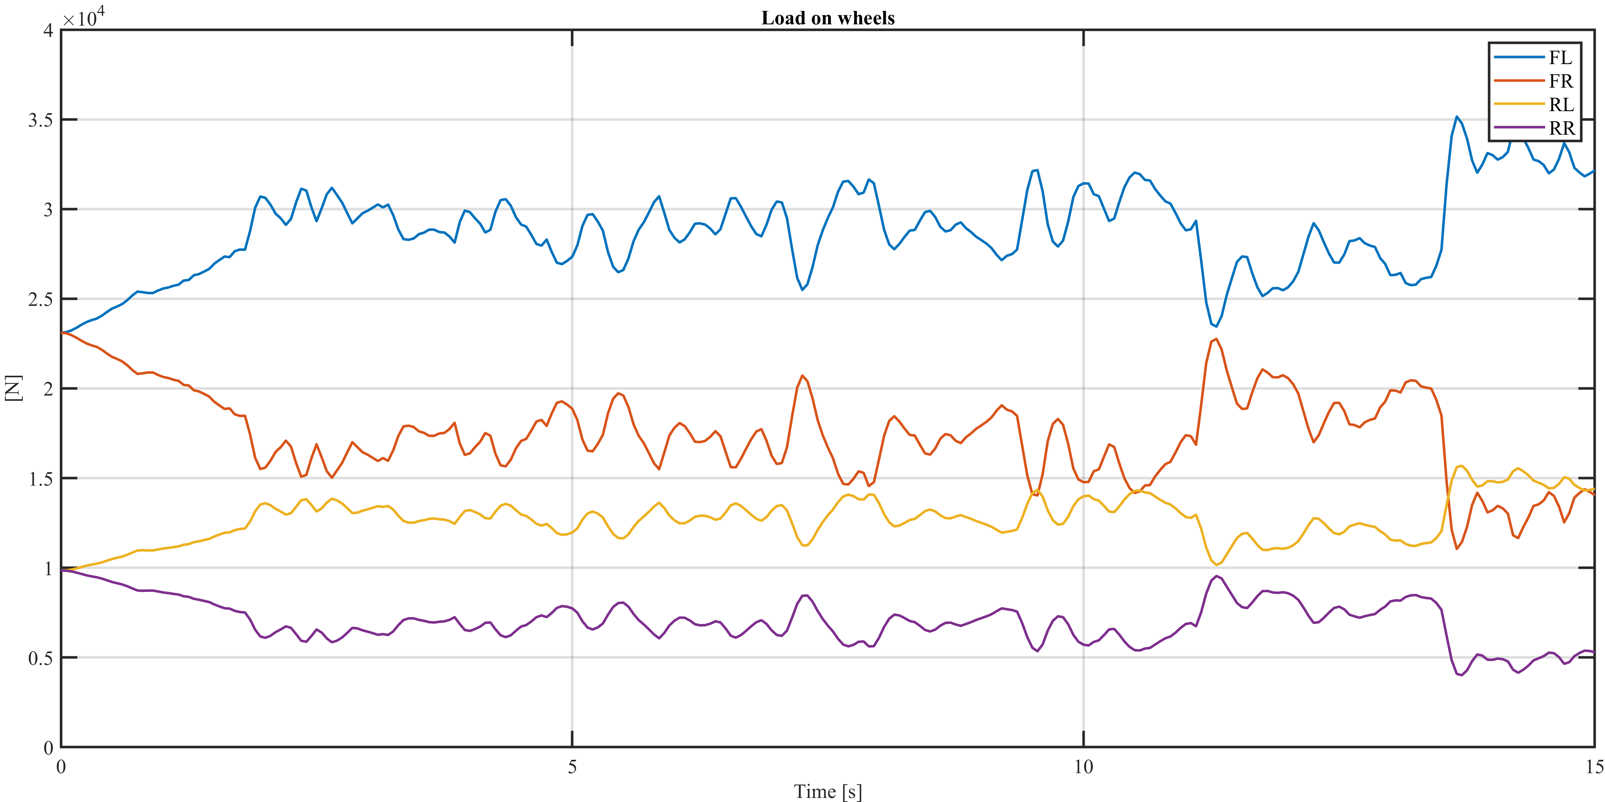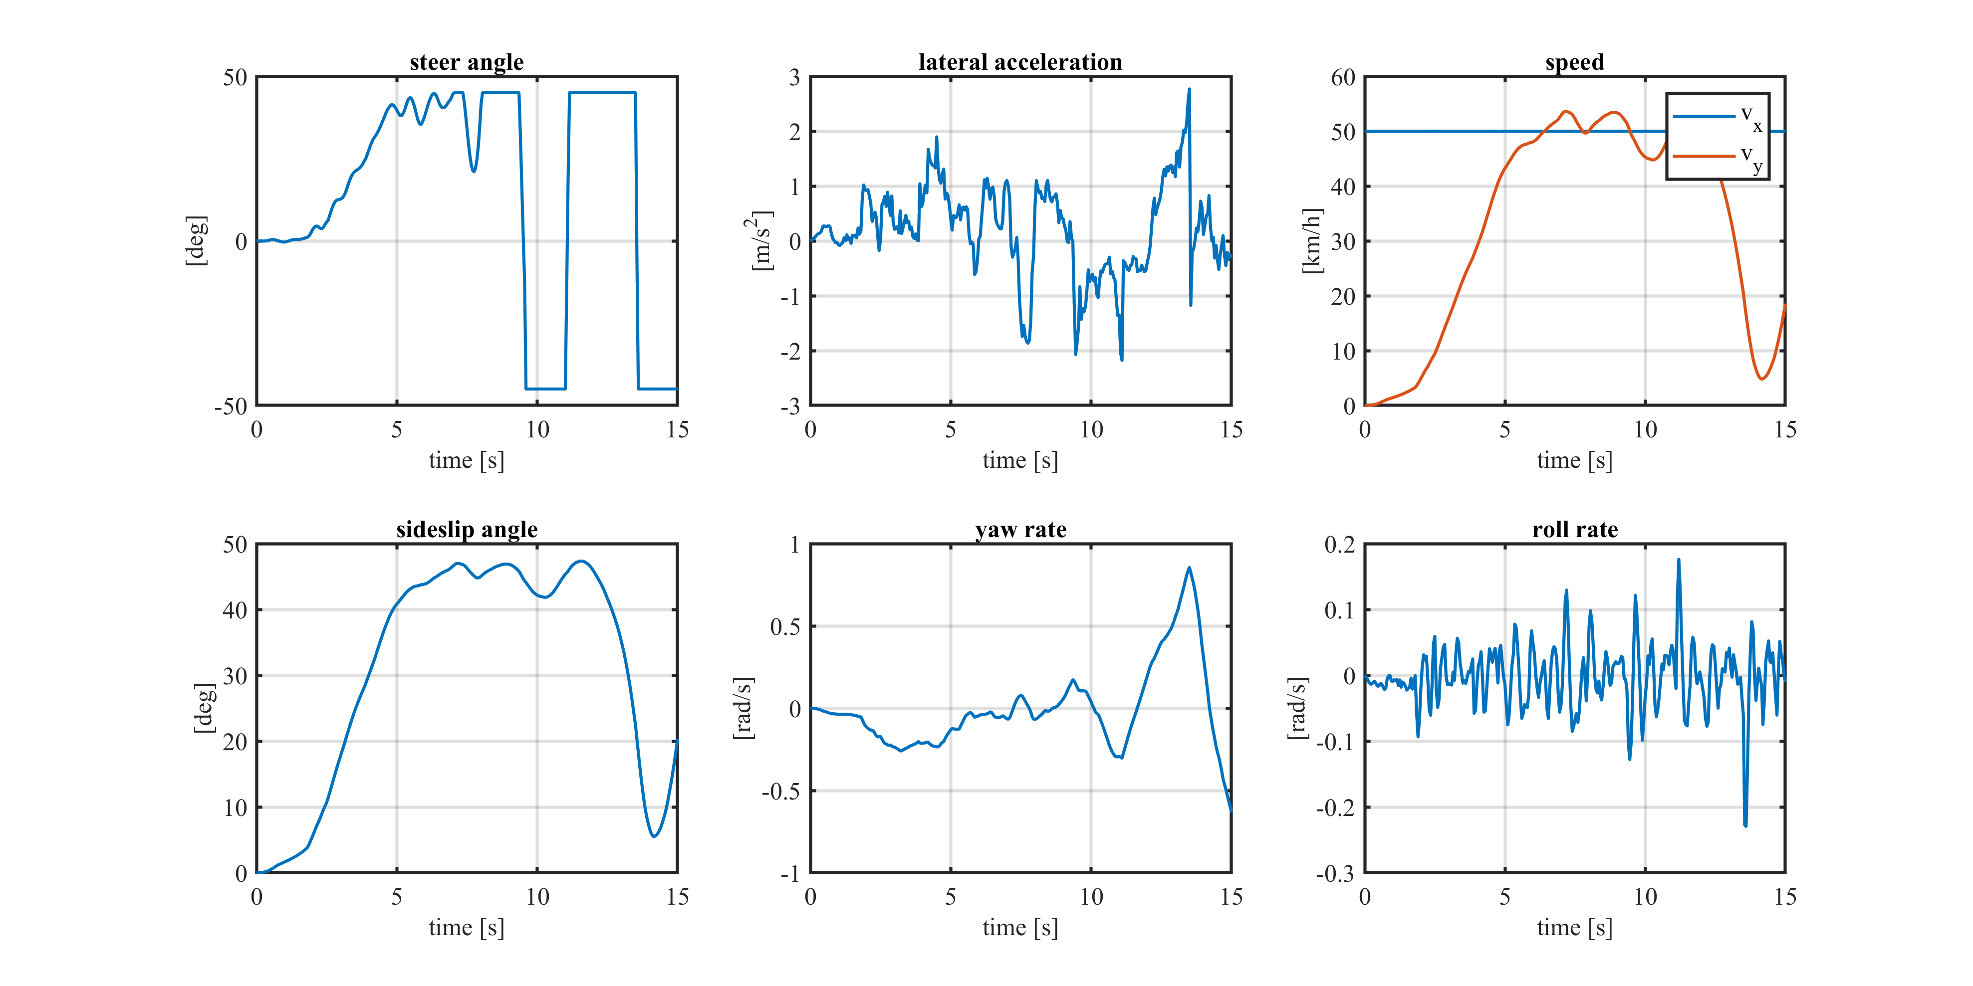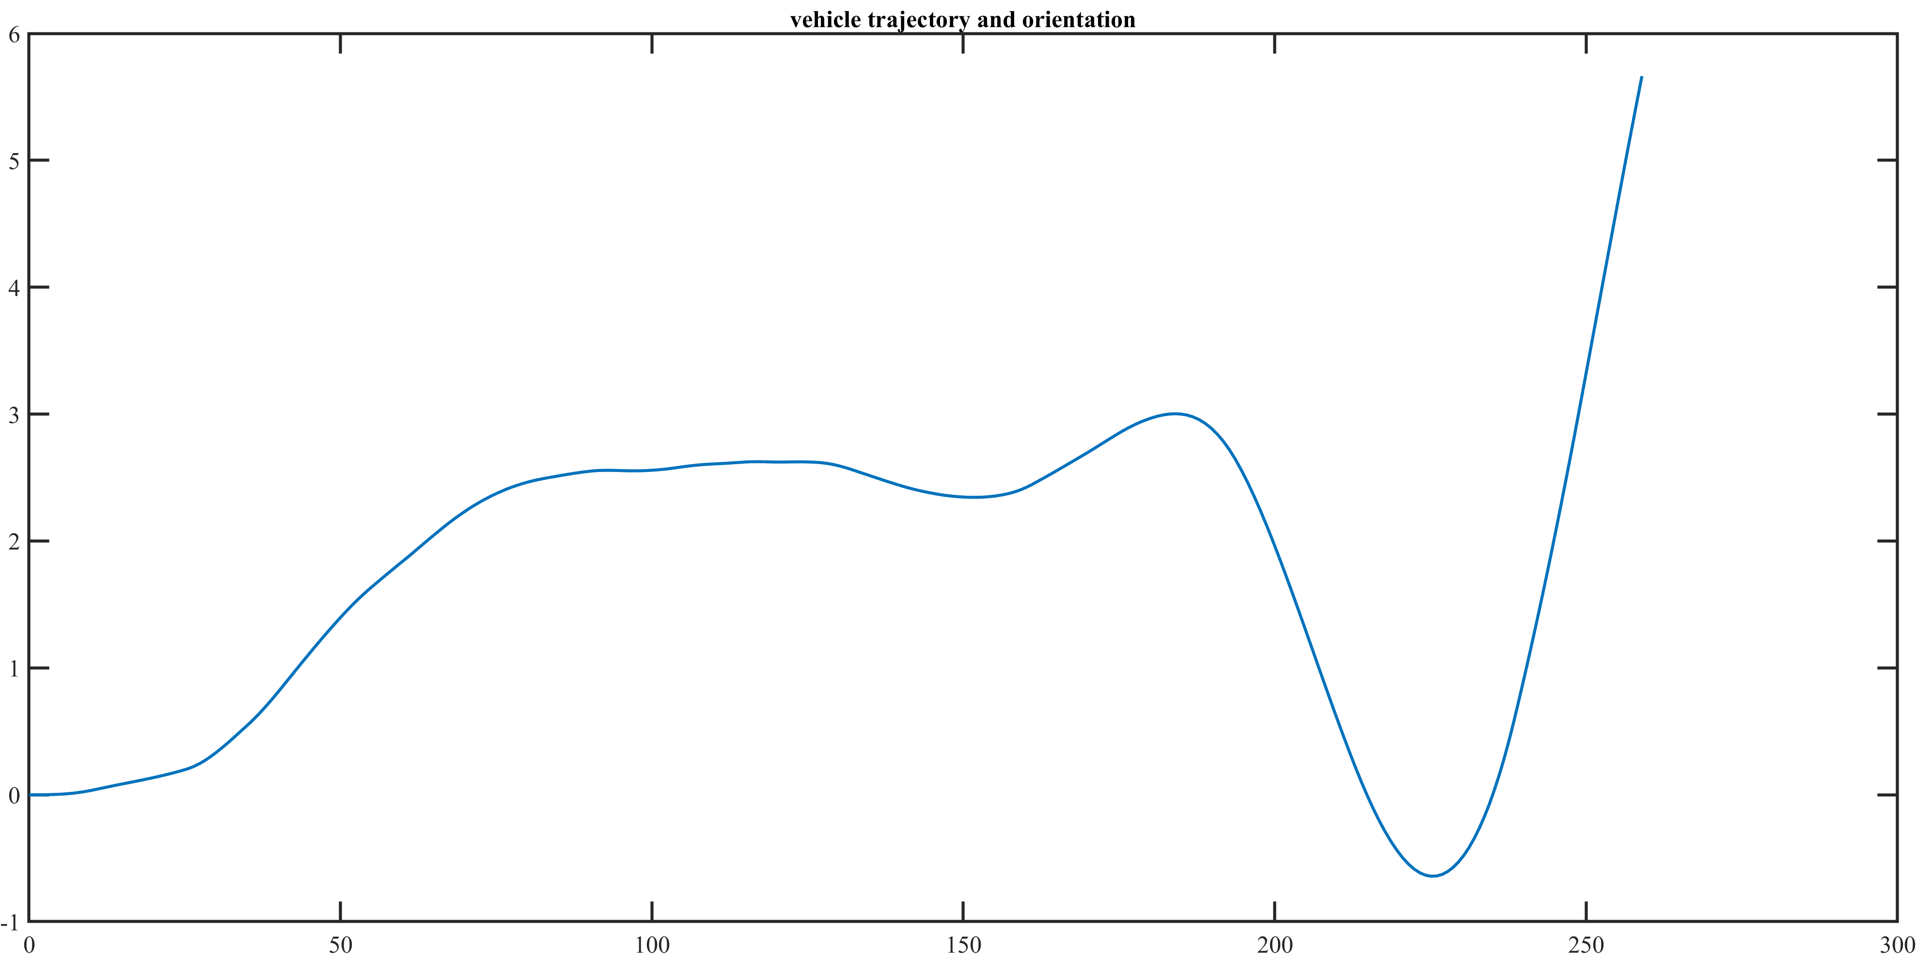

Lambda = 0.75, Dry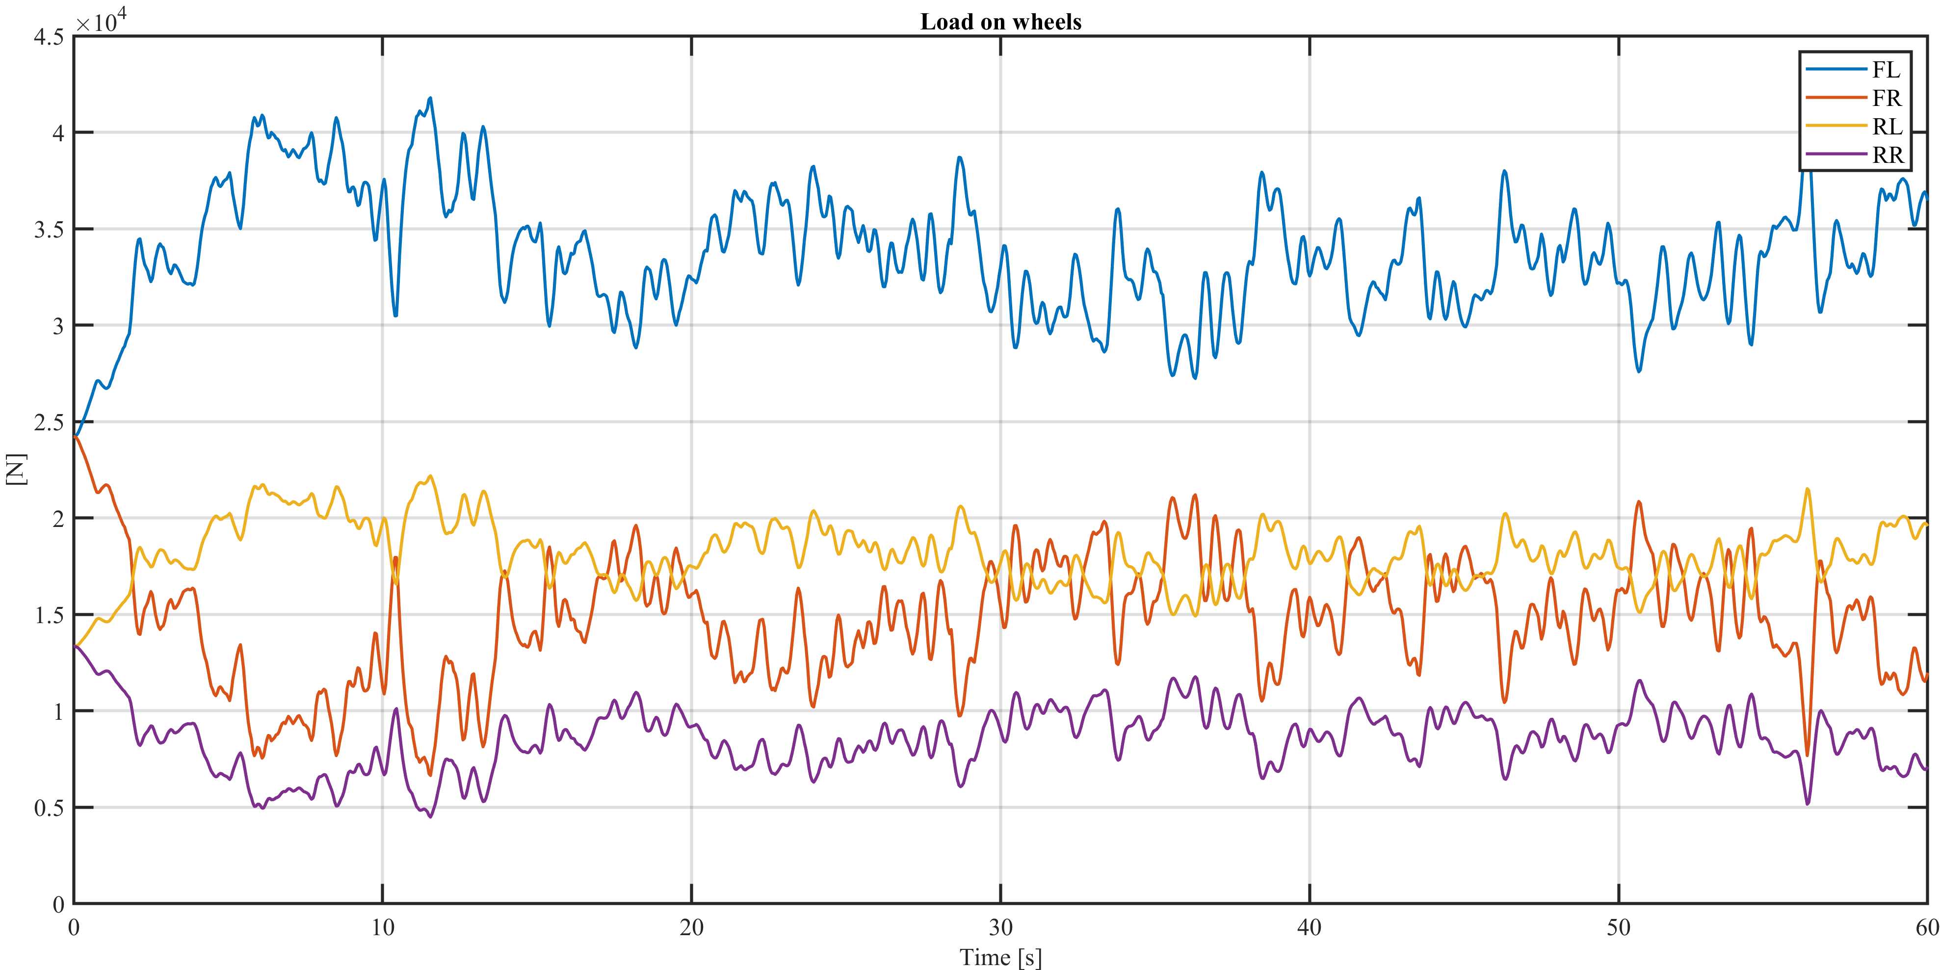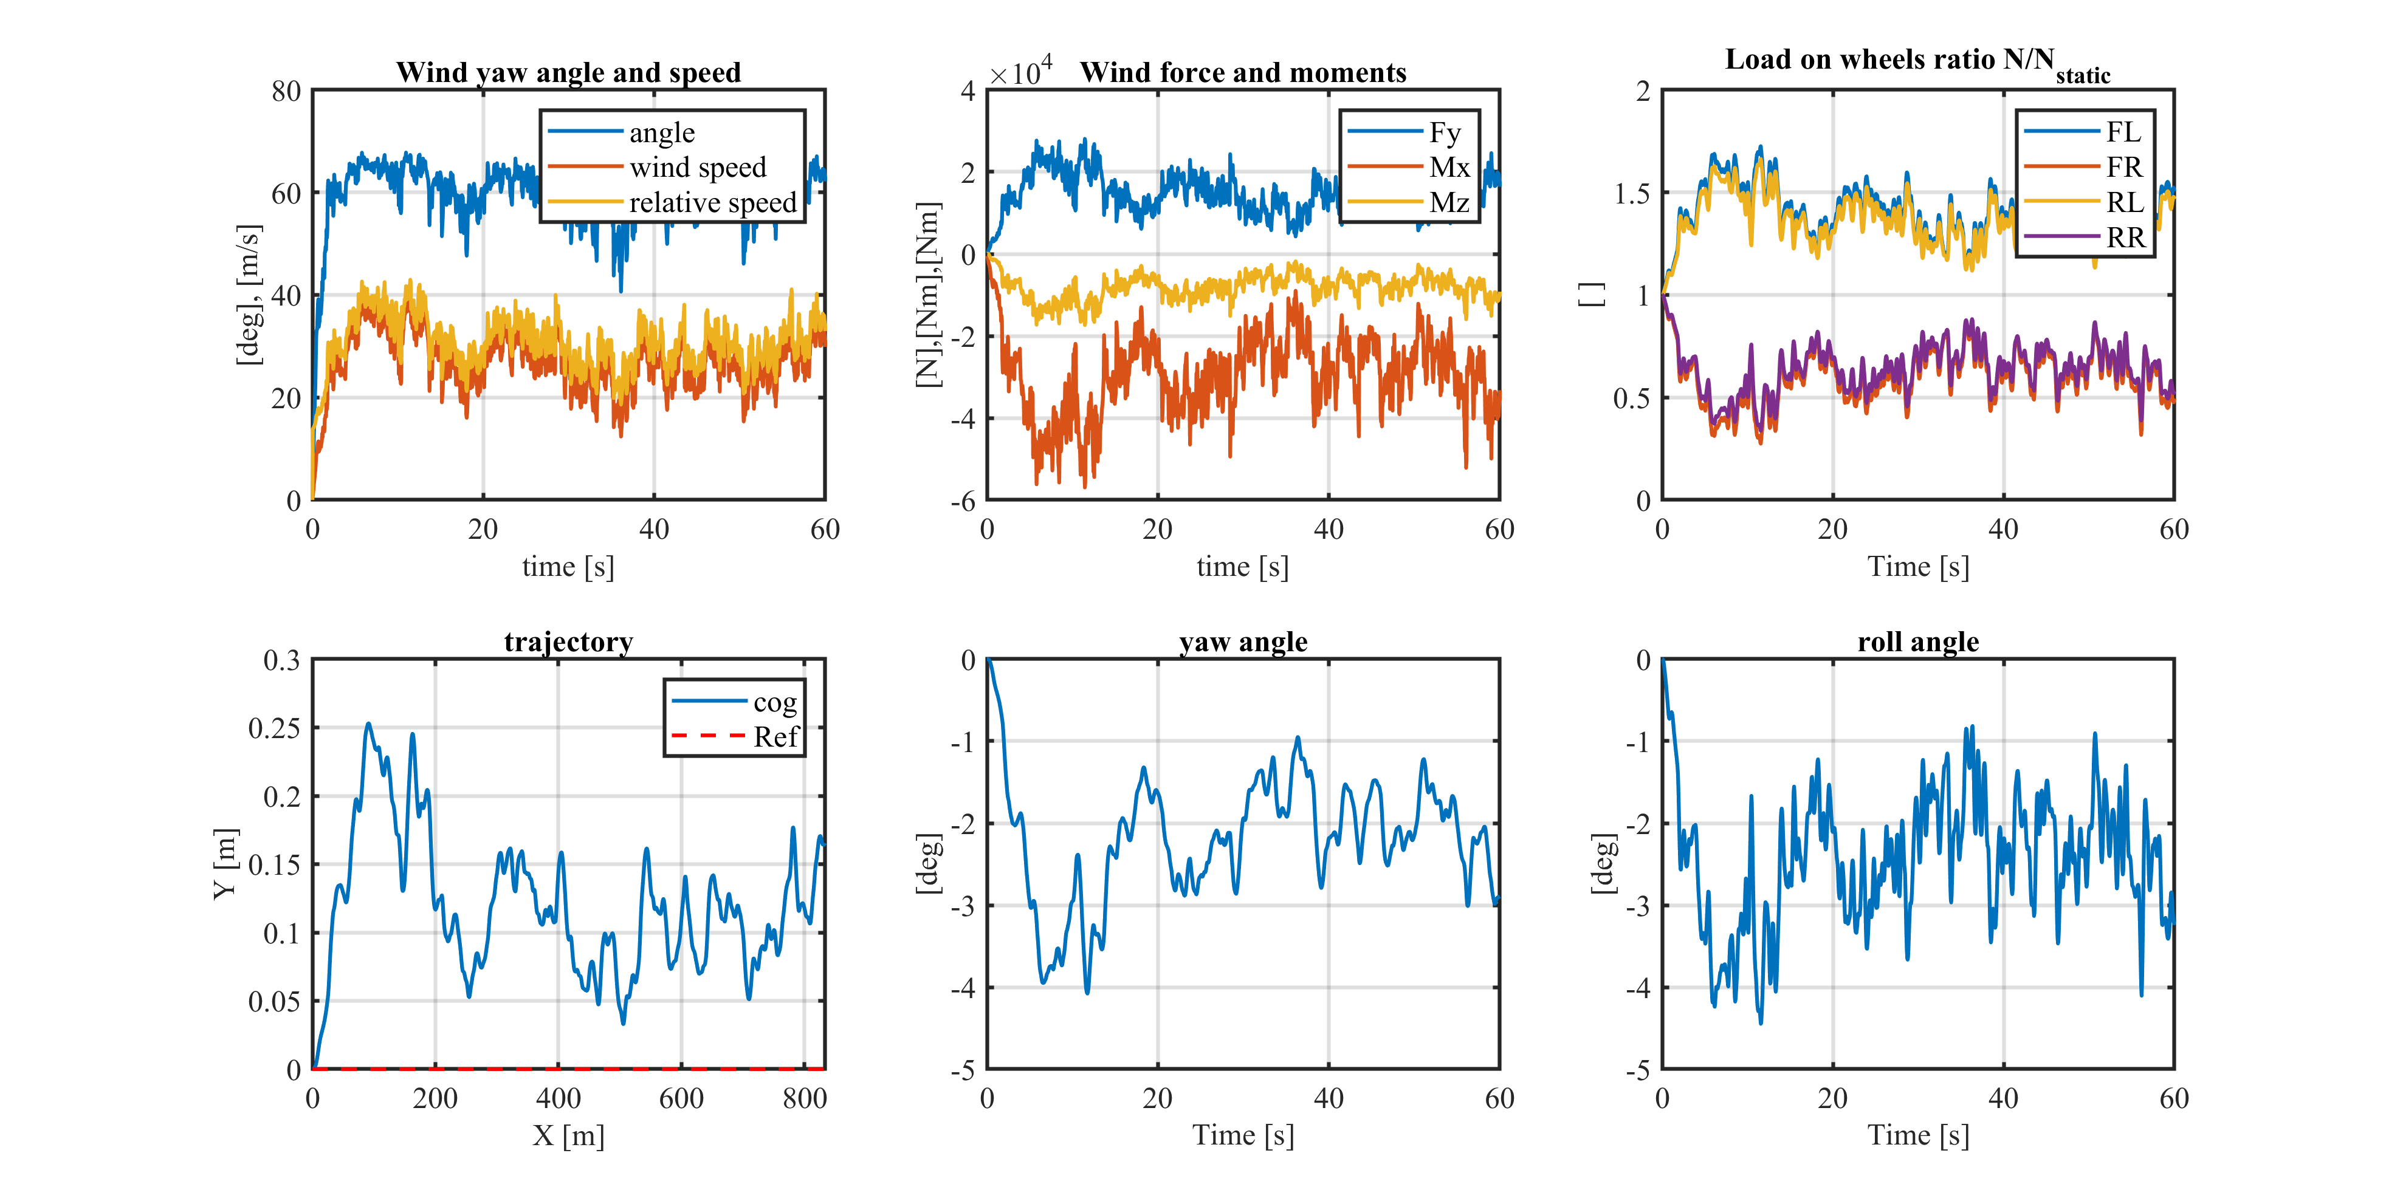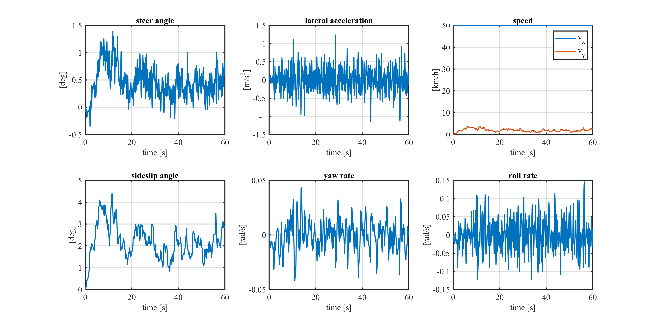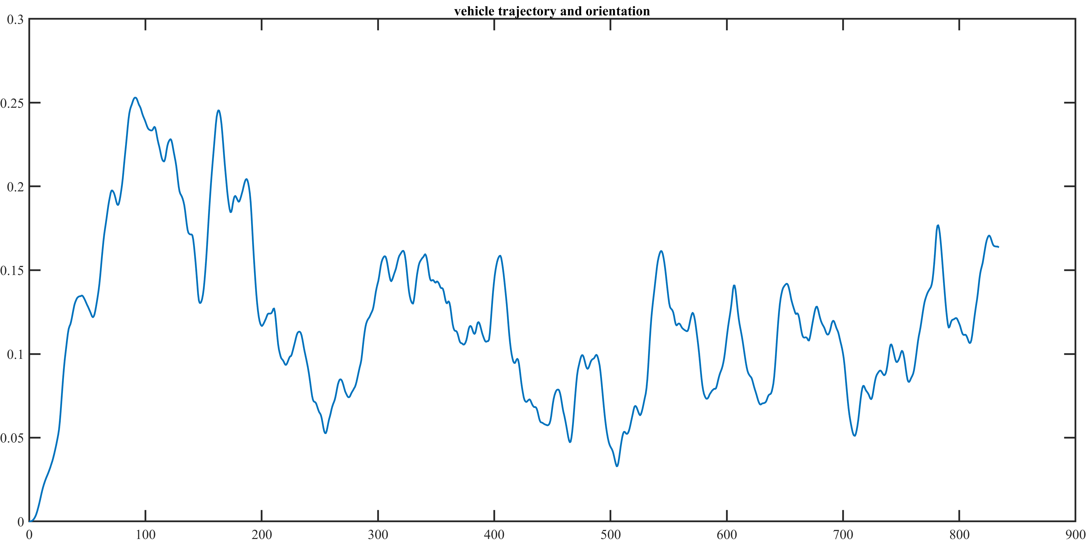, far vedere che in questo caso siamo safe

Lambda = 0.75, Wet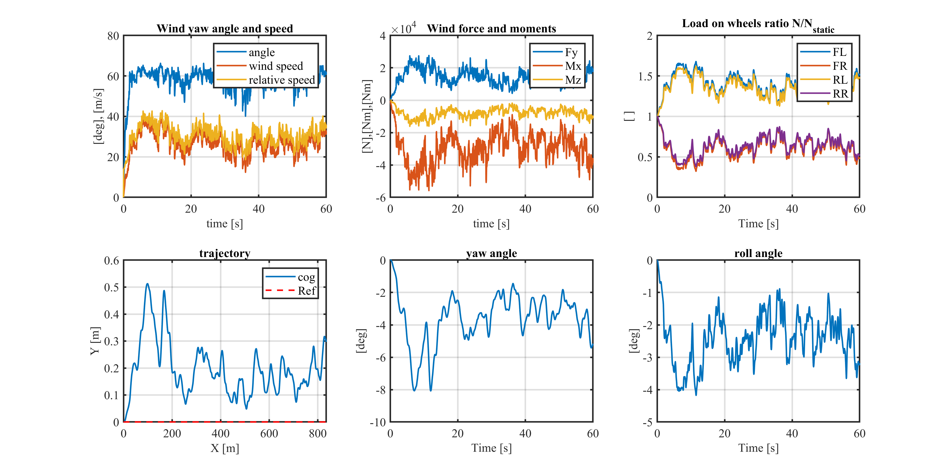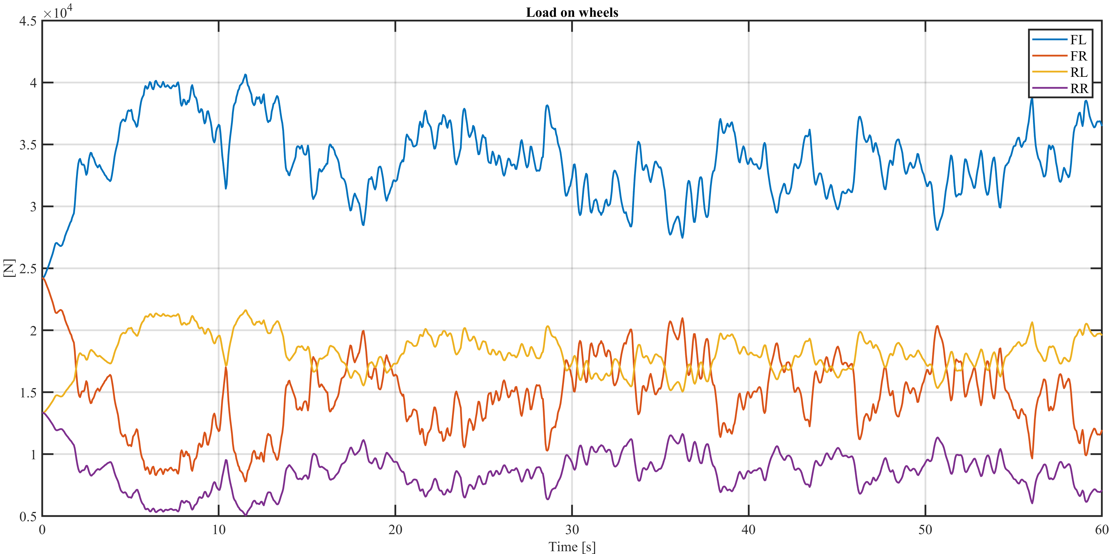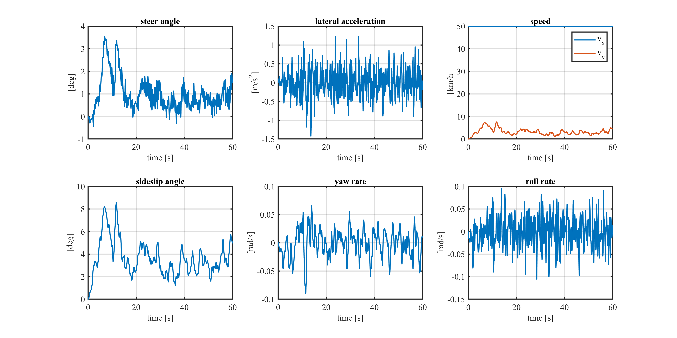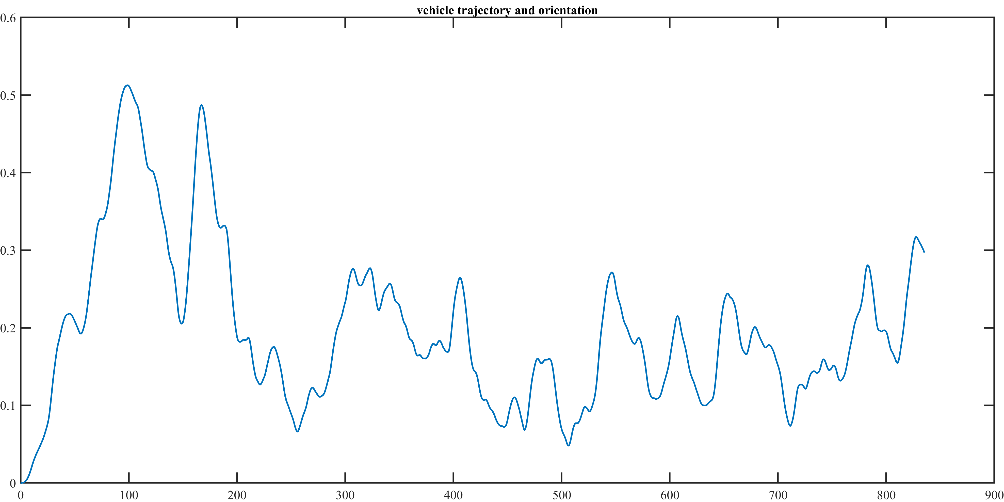

Lambda = 0.75, Snow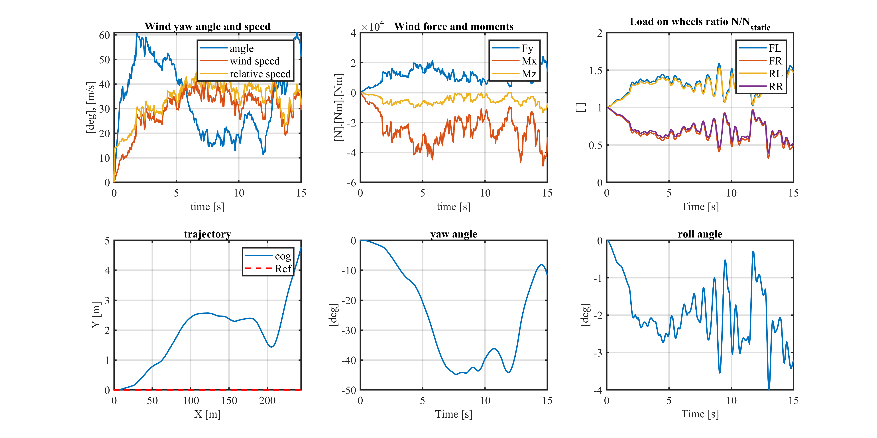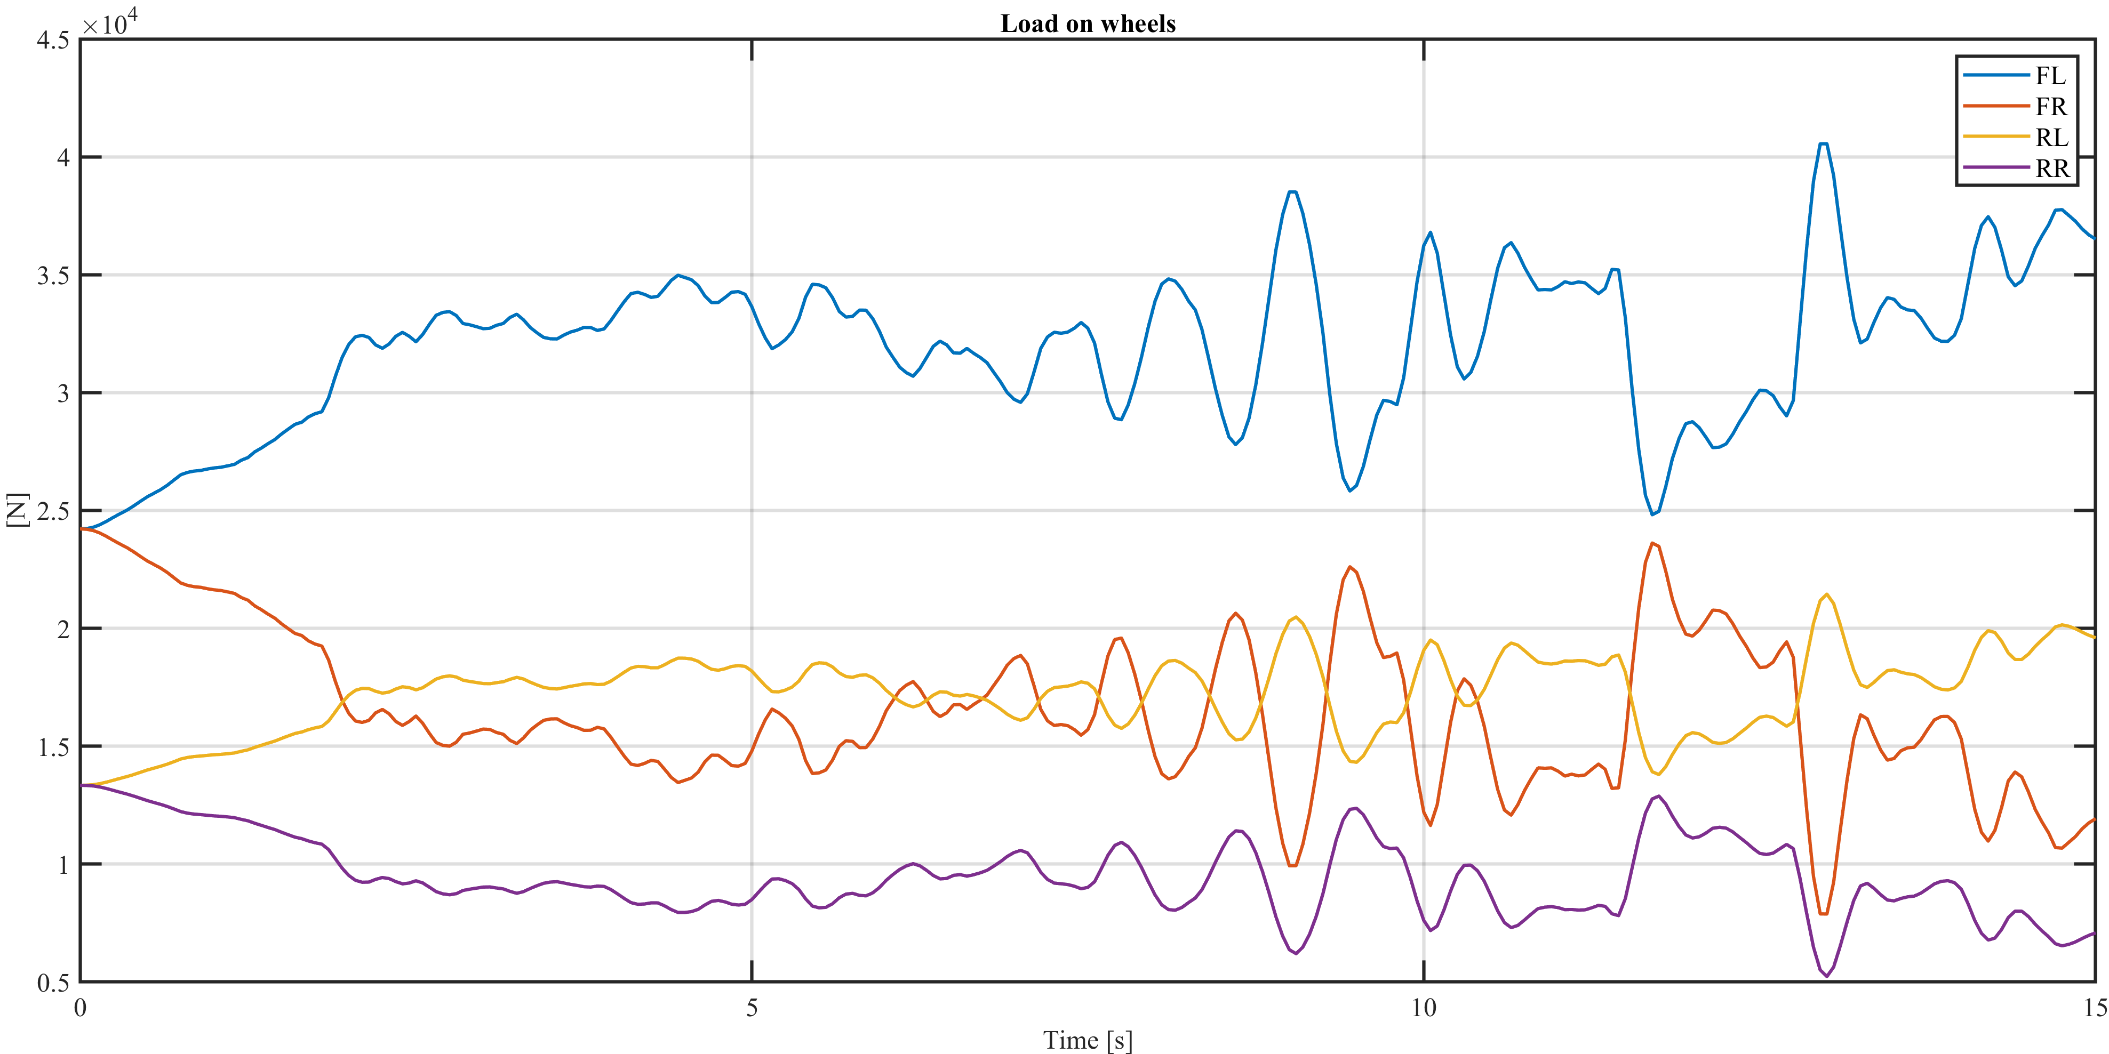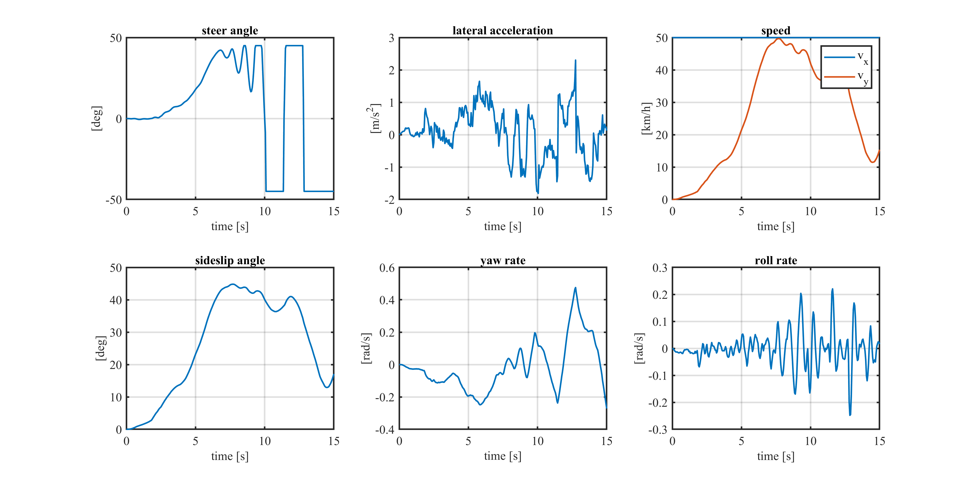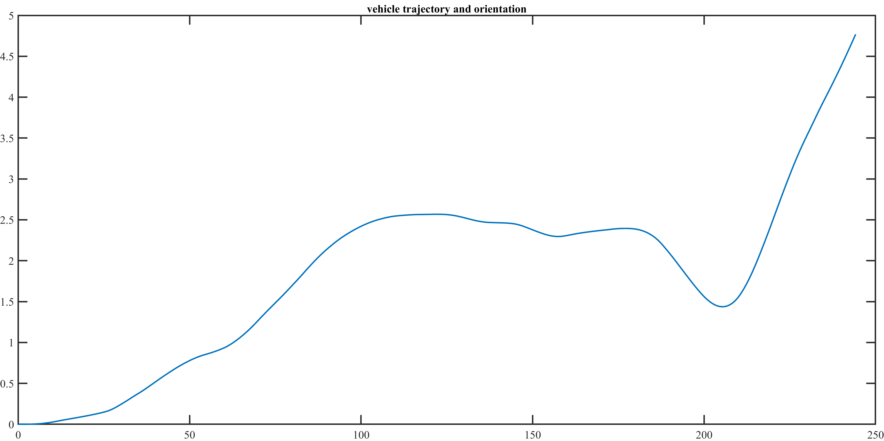

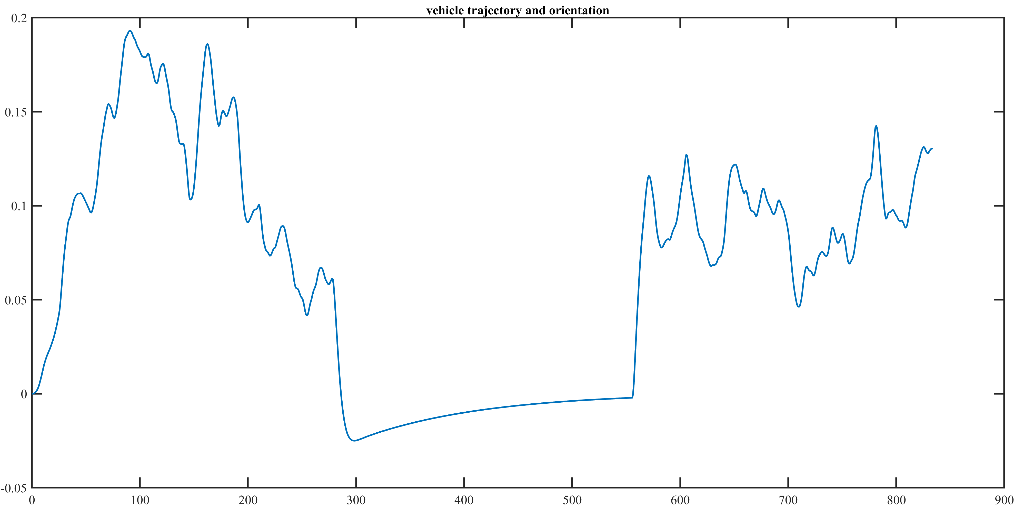Simulazione galleria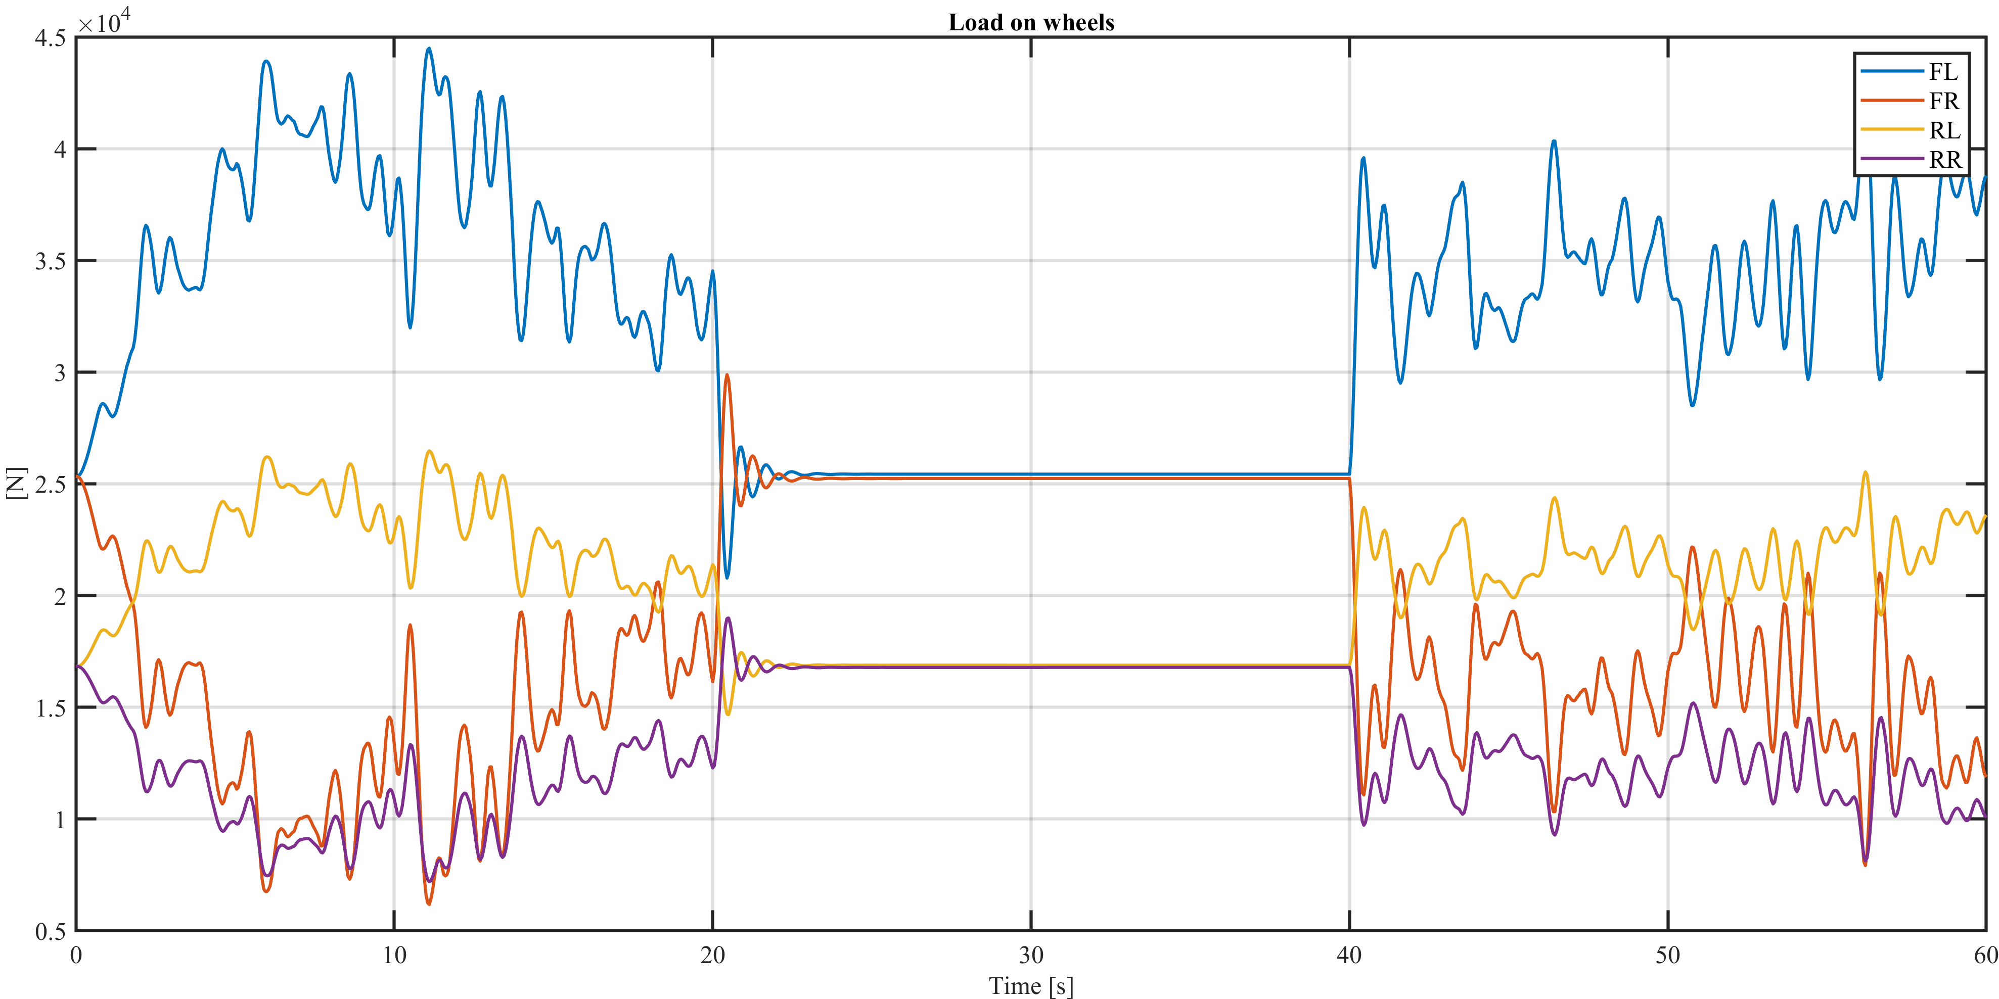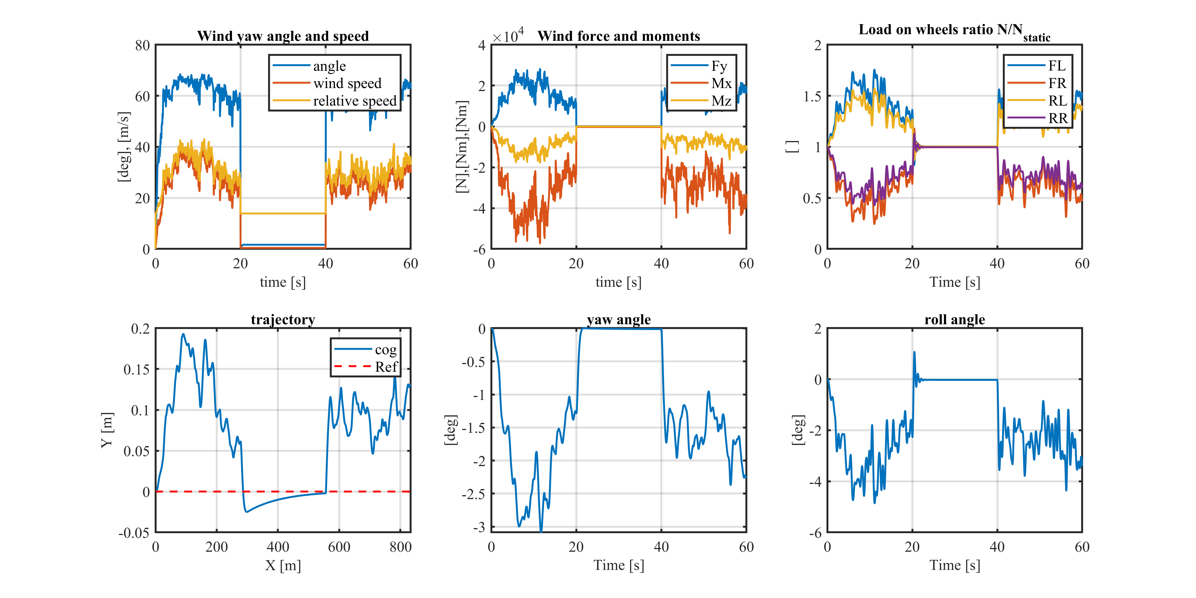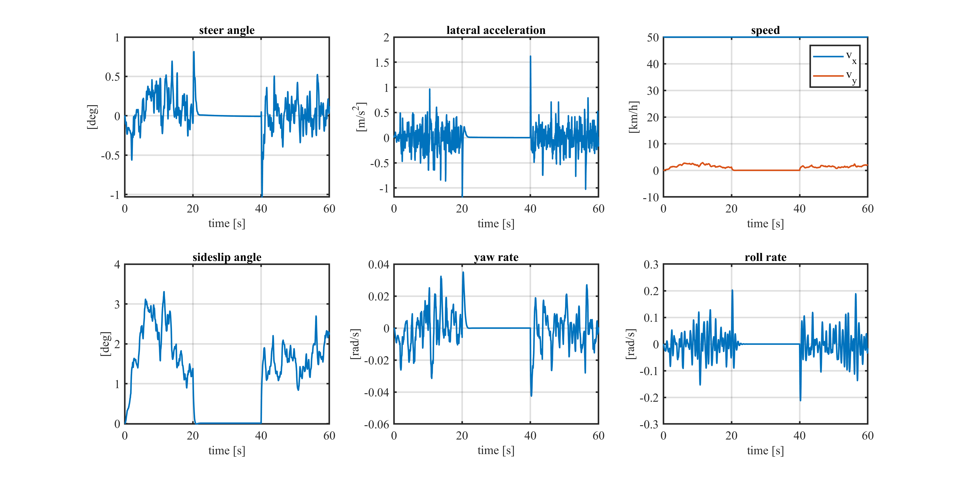: Io metterei foto traiettoria, Load on Wheels, roll angle e wind yaw angle and wind speed

# TAU ROLL ANALYSIS

### DRY CONDITION

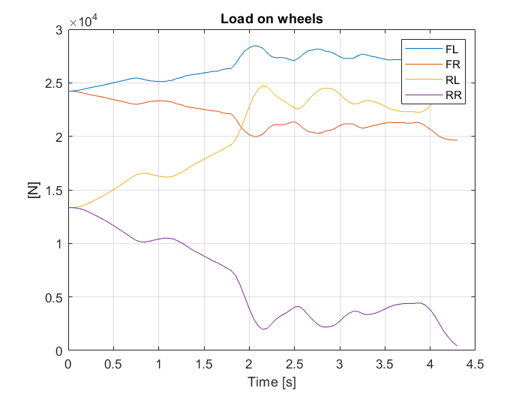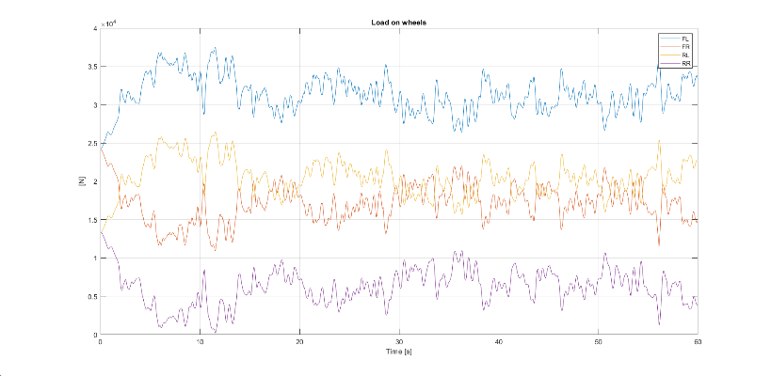

Tau_roll=0.25 Tau_roll=0.5

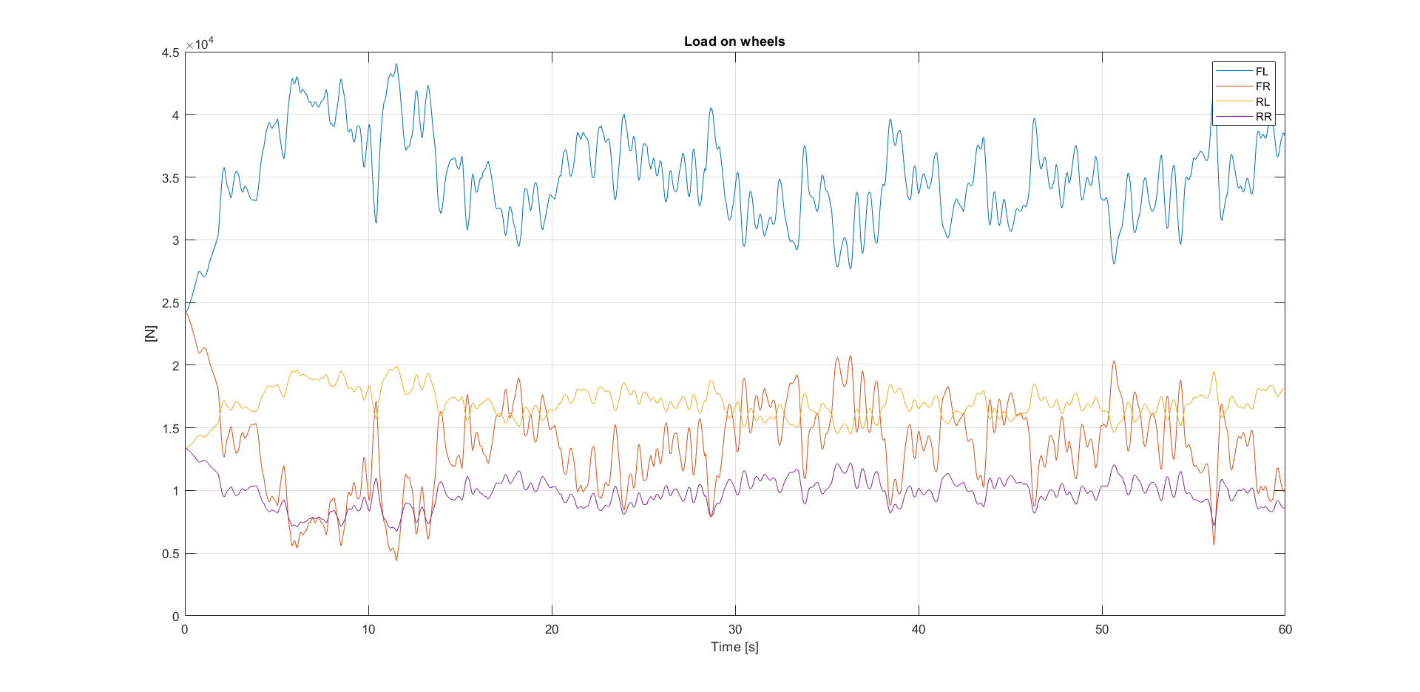

Tau_roll=0.75

No main differences are visible in the yaw, roll, steer and trajectory parameters. The main variation is visible in the distribution of the load over the front and rear axle. With lower tau_roll (hence stiffer rear axle) a large load transfer is observed between the two rear wheels. This reduces significantly the load on the upwind wheel causing rollover.

Increasing tau_roll we get a much lower load transfer on the rear axle and an increasing one on the front. However the front axle has a higher initial load, so the load transfer does not bring to rollover but with tau_roll=0.5 we can see that the load on the RR wheel is still very close to 0 so a critical situation is observed.

In the end tau_roll=0.75 seems to give a fair margin on the rollover given the initial load distribution.

### DRY-WET-SNOW CONDITIONS at TAU_ROLL=0.75

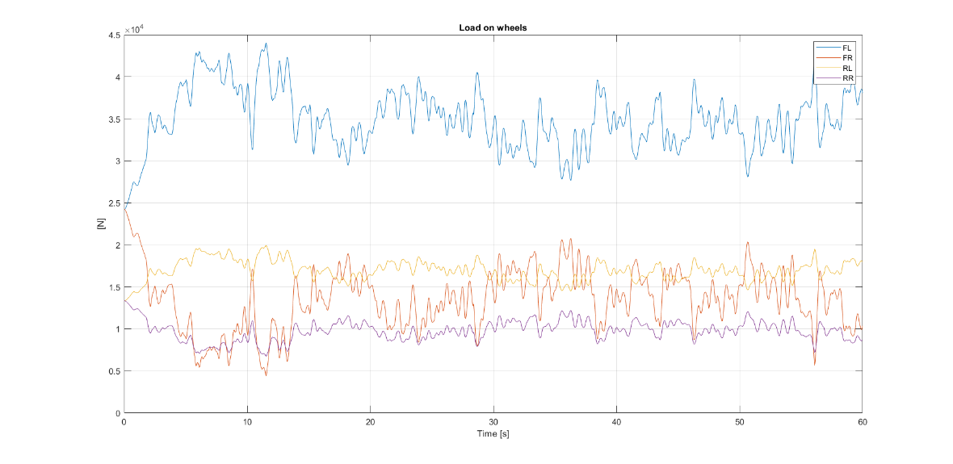

Dry condition

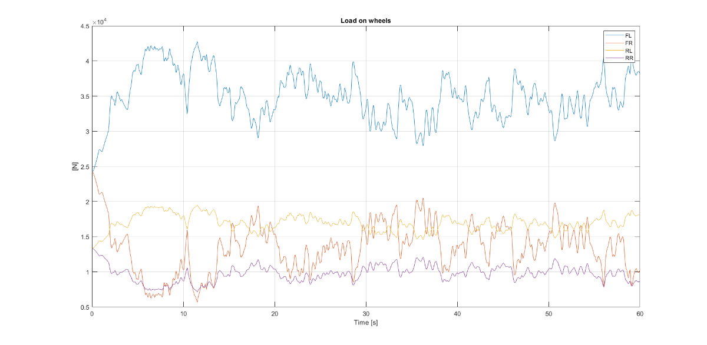

Wet condition

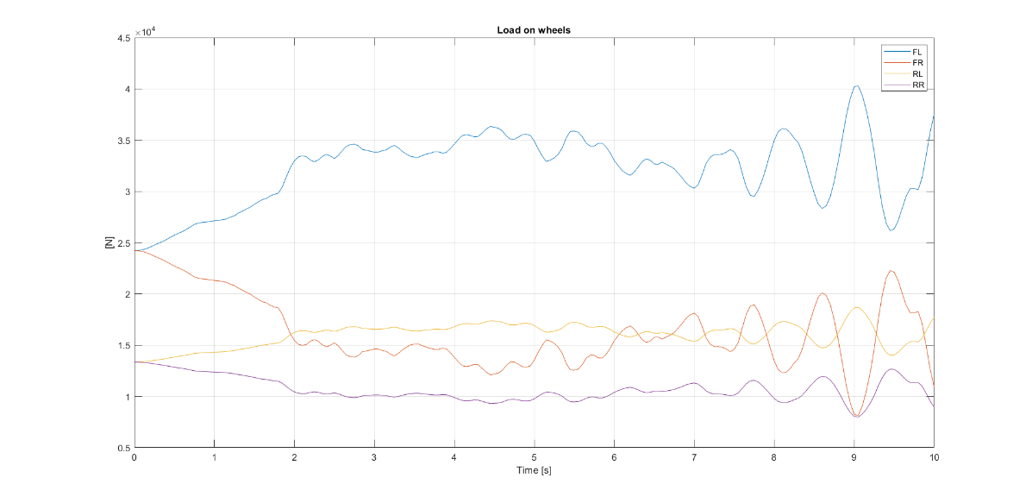

Snow condition

No main differences are observed between the dry and the wet case, however a big difference is present in the snow case. Here the driver input arrives at the steering limit to avoid going out of the trajectory and this produces a strong instability in the response of the car. The simulation is therefore stopped, but of course the vehicle would reach rollover. The issue is due to the fact that the driver increases continuously the steer angle but at some point oversteer occurs (see yaw rate peak) and the driver overreacts. This produces the opposite effect and an unstable behaviour is induced.

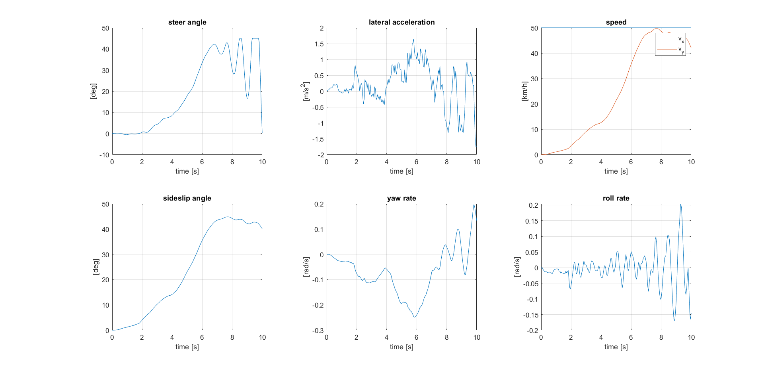

Snow condition

# LANE CHANGE ANALYSIS

### DRY-WET-SNOW CONDITIONS

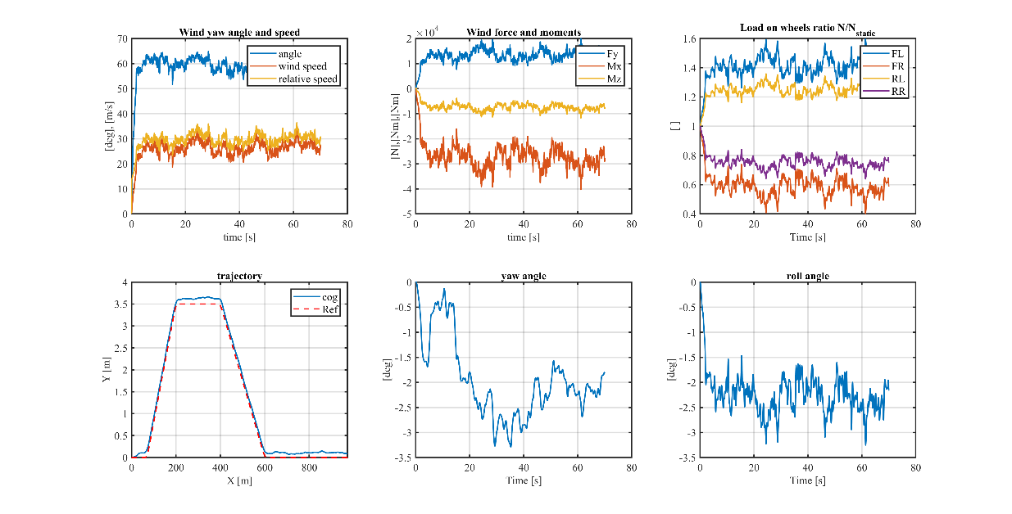

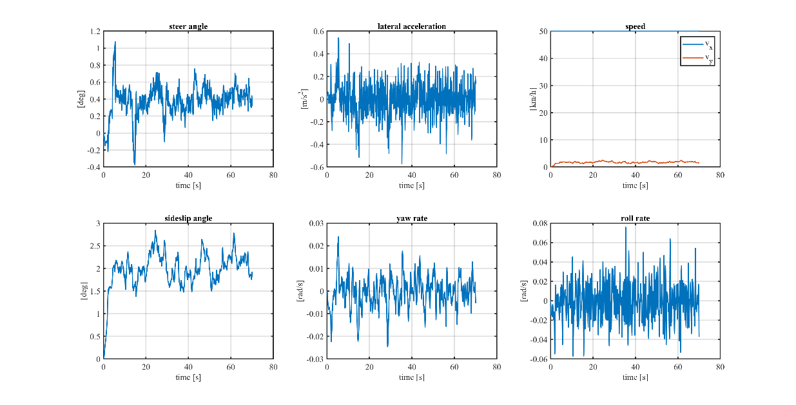

Dry condition

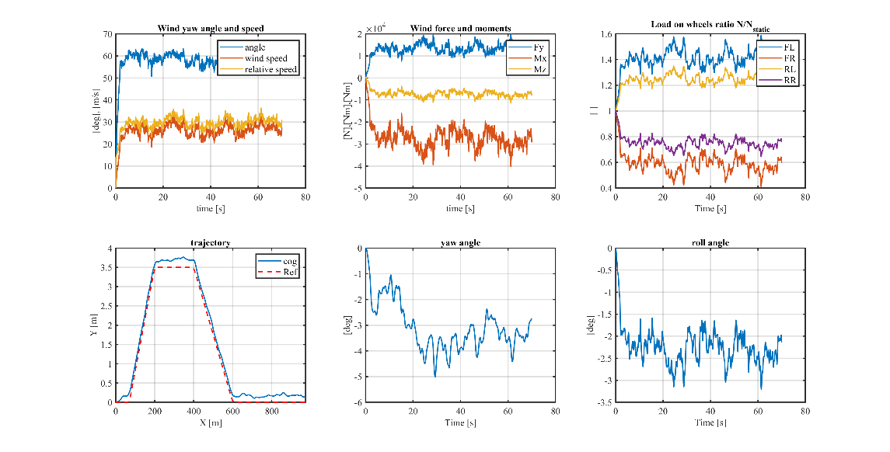

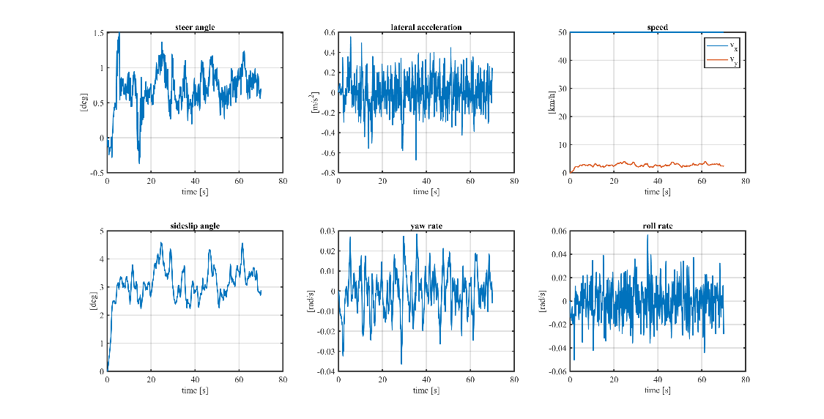

Wet condition

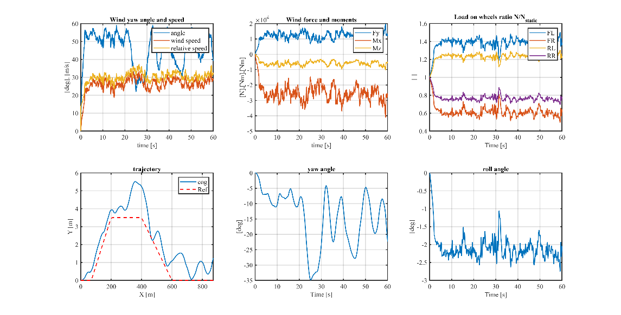

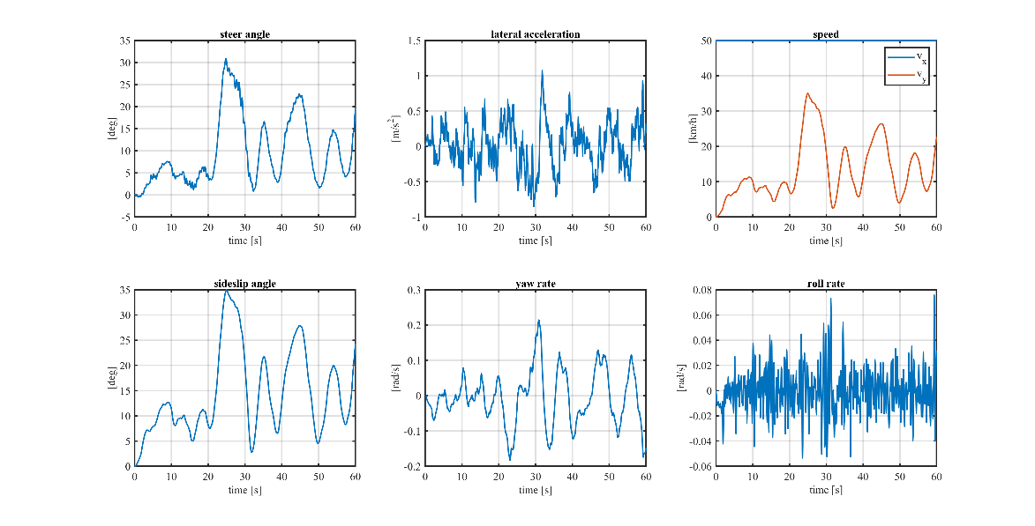

Snow condition

In the wet condition a more unstable trajectory can be observed together with larger yaw angles with respect to the dry case. The reduced grip causes the driver to react with more steer angle to produce enough lateral force to obtain similar lateral accelerations.

In the snow condition the lane change produces a perturbation such that the driver reacts with a strong steering angle and again an unstable behaviour is observed.